1 A local university has a current enrollment of 12,000 students. The enrollment is increasing continuously at a rate of 2.5% each year. Which logarithm is equal to the number of years it will take for the population to increase to 15,000 students?
1) | 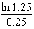
2) | 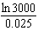
3) | 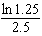
4) | 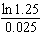

2 Judith puts $5000 into an investment account with interest compounded continuously. Which approximate annual rate is needed for the account to grow to $9110 after 30 years?
1) | 2%
2) | 2.2%
3) | 0.02%
4) | 0.022%

3 In New York State, the minimum wage has grown exponentially. In 1966, the minimum wage was $1.25 an hour and in 2015, it was $8.75. Algebraically determine the rate of growth to the nearest percent.

4 A house purchased 5 years ago for $100,000 was just sold for $135,000. Assuming exponential growth, approximate the annual growth rate, to the nearest percent.

5 Determine, to the nearest tenth of a year, how long it would take an investment to double at a 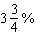 interest rate, compounded continuously.

6 When observed by researchers under a microscope, a smartphone screen contained approximately 11,000 bacteria per square inch. Bacteria, under normal conditions, double in population every 20 minutes.
a) Assuming an initial value of 11,000 bacteria, write a function, , that can be used to model the population of bacteria, p, on a smartphone screen, where t represents the time in minutes after it is first observed under a microscope.
b) Using from part a, determine algebraically, to the nearest hundredth of a minute, the amount of time it would take for a smartphone screen that was not touched or cleaned to have a population of 1,000,000 bacteria per square inch.

7 Carla wants to start a college fund for her daughter Lila. She puts $63,000 into an account that grows at a rate of 2.55% per year, compounded monthly. Write a function, , that represents the amount of money in the account t years after the account is opened, given that no more money is deposited into or withdrawn from the account. Calculate algebraically the number of years it will take for the account to reach $100,000, to the nearest hundredth of a year.

8 Seth’s parents gave him $5000 to invest for his 16th birthday. He is considering two investment options. Option A will pay him 4.5% interest compounded annually. Option B will pay him 4.6% compounded quarterly. Write a function of option A and option B that calculates the value of each account after n years. Seth plans to use the money after he graduates from college in 6 years. Determine how much more money option B will earn than option A to the nearest cent. Algebraically determine, to the nearest tenth of a year, how long it would take for option B to double Seth’s initial investment.

9 The Manford family started savings accounts for their twins, Abby and Brett, on the day they were born. They invested $8000 in an account for each child. Abby’s account pays 4.2% annual interest compounded quarterly. Brett’s account pays 3.9% annual interest compounded continuously. Write a function, , for Abby’s account and a function, , for Brett’s account that calculates the value of each account after t years. Determine who will have more money in their account when the twins turn 18 years old, and find the difference in the amounts in the accounts to the nearest cent. Algebraically determine, to the nearest tenth of a year, how long it takes for Brett’s account to triple in value.

10 Taylor wants to open an investment account with the $1200 she received for her birthday. She has narrowed her choices down to two banks. America's Bank offers 6.4% annual interest compounded quarterly. Barnyard Bank offers 6.35% annual interest compounded continuously. Write functions for and to represent the value of her investment with America's Bank and Barnyard Bank as a function of time, t, in years. Taylor would like to invest the $1200 into one bank for ten years making no additional deposits and no withdrawals. With which bank will Taylor earn the most money? Justify your answer. Taylor chooses to invest her money in Barnyard Bank. Algebraically determine how long, to the nearest tenth of a year, it will take her initial investment to triple assuming she makes no deposits or withdrawals.

11 Monthly mortgage payments can be found using the formula below:

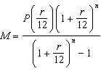

M = monthly payment
P = amount borrowed
r = annual interest rate
n = number of monthly payments

The Banks family would like to borrow $120,000 to purchase a home. They qualified for an annual interest rate of 4.8%. Algebraically determine the fewest number of whole years the Banks family would need to include in the mortgage agreement in order to have a monthly payment of no more than $720.

12 After sitting out of the refrigerator for a while, a turkey at room temperature (68°F) is placed into an oven at 8 a.m., when the oven temperature is 325°F. Newton’s Law of Heating explains that the temperature of the turkey will increase proportionally to the difference between the temperature of the turkey and the temperature of the oven, as given by the formula below:

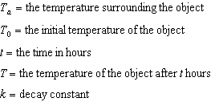

The turkey reaches the temperature of approximately 100° F after 2 hours. Find the value of k, to the nearest thousandth, and write an equation to determine the temperature of the turkey after t hours. Determine the Fahrenheit temperature of the turkey, to the nearest degree, at 3 p.m.

13 Tony is evaluating his retirement savings. He currently has $318,000 in his account, which earns an interest rate of 7% compounded annually. He wants to determine how much he will have in the account in the future, even if he makes no additional contributions to the account. Write a function, , to represent the amount of money that will be in his account in t years. Graph where on the set of axes below.

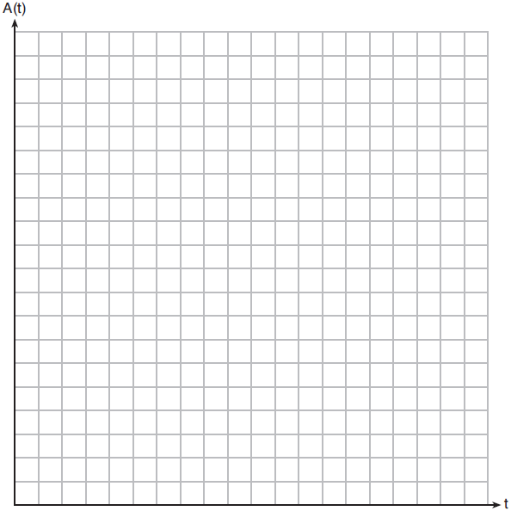

Tony's goal is to save $1,000,000. Determine algebraically, to the nearest year, how many years it will take for him to achieve his goal. Explain how your graph of confirms your answer.

14 A retailer advertises that items will be discounted by 10% every Monday until they are sold. In how many weeks will an item costing $50 first be sold for under half price?
1) | 7
2) | 6
3) | 5
4) | 4

15 The half-life of iodine-131 is 8 days. The percent of the isotope left in the body d days after being introduced is 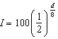. When this equation is written in terms of the number e, the base of the natural logarithm, it is equivalent to . What is the approximate value of the constant, k?
1)
2) | 0.087
3)
4) | 11.542

16 The Fahrenheit temperature, , of a heated object at time t, in minutes, can be modeled by the function below. is the surrounding temperature, is the initial temperature of the object, and k is a constant.
Coffee at a temperature of 195°F is poured into a container. The room temperature is kept at a constant 68°F and . Coffee is safe to drink when its temperature is, at most, 120°F. To the nearest minute, how long will it take until the coffee is safe to drink?
1) | 7
2) | 10
3) | 11
4) | 18

17 One of the medical uses of Iodine–131 (I–131), a radioactive isotope of iodine, is to enhance x-ray images. The half-life of I–131 is approximately 8.02 days. A patient is injected with 20 milligrams of I–131. Determine, to the nearest day, the amount of time needed before the amount of I–131 in the patient’s body is approximately 7 milligrams.

18 The half-life of a radioactive substance is 15 years. Write an equation that can be used to determine the amount, , of 200 grams of this substance that remains after t years. Determine algebraically, to the nearest year, how long it will take for of this substance to remain.

19 A radioactive substance has a mass of 140 g at 3 p.m. and 100 g at 8 p.m. Write an equation in the form 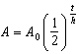 that models this situation, where h is the constant representing the number of hours in the half-life, is the initial mass, and A is the mass t hours after 3 p.m. Using this equation, solve for h, to the nearest ten thousandth. Determine when the mass of the radioactive substance will be 40 g. Round your answer to the nearest tenth of an hour.

20 Megan is performing an experiment in a lab where the air temperature is a constant 73ºF and the liquid is 237ºF. One and a half hours later, the temperature of the liquid is 112ºF. Newton's law of cooling states where:
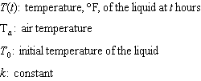
Determine the value of k, to the nearest thousandth, for this liquid. Determine the temperature of the liquid using your value for k, to the nearest degree, after two and a half hours. Megan needs the temperature of the liquid to be 80ºF to perform the next step in her experiment. Use your value for k to determine, to the nearest tenth of an hour, how much time she must wait since she first began the experiment.
1 ANS: 4
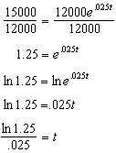

REF: 082209aii

2 ANS: 1
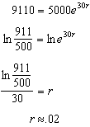

REF: 011810aii

3 ANS:
4% 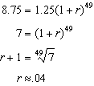 or 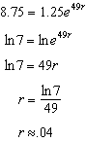

REF: 081730aii

4 ANS:
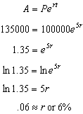

REF: 061632aii

5 ANS:
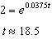

REF: 081835aii

6 ANS:
a) 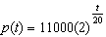; b) 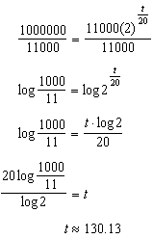

REF: 082233aii

7 ANS:
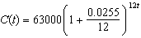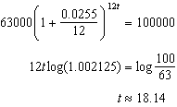

REF: 061835aii

8 ANS:
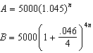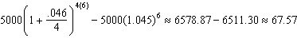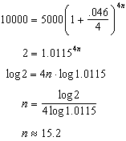

REF: 081637aii

9 ANS:
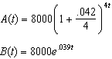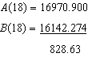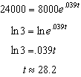

REF: 082337aii

10 ANS:
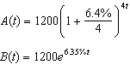 Barnyard because 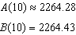 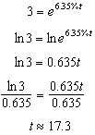

REF: 082437aii

11 ANS:
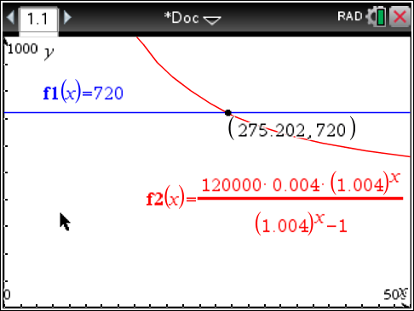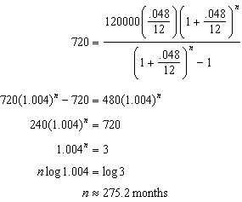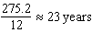

REF: spr1509aii

12 ANS:
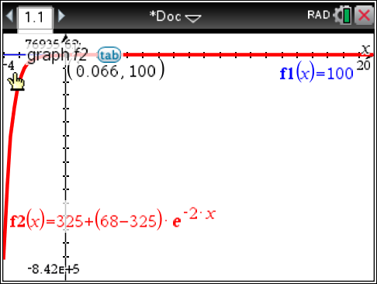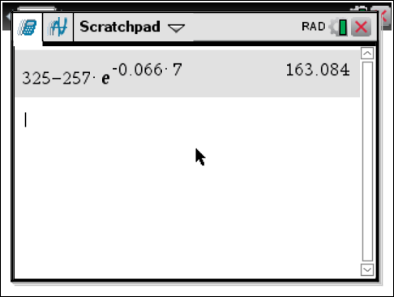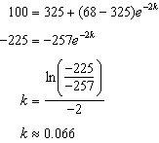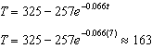

REF: fall1513aii

13 ANS:
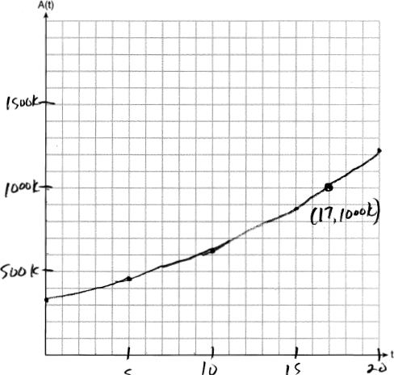 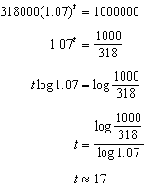 The graph of nearly intersects the point .

REF: 011937aii

14 ANS: 1
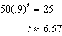

REF: 082317aii

15 ANS: 1
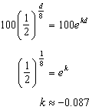

REF: 061818aii

16 ANS: 4
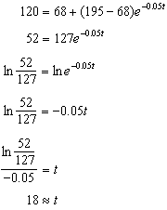

REF: 081918aii

17 ANS:
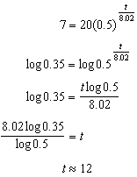

REF: 081634aii

18 ANS:
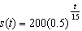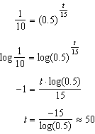

REF: 061934aii

19 ANS:
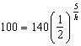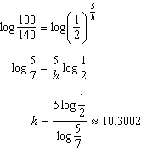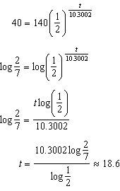

REF: 061737aii

20 ANS:
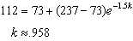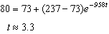

REF: 062437aii

