1 A sprinkler system is set up to water the sector shown in the accompanying diagram, with angle ABC measuring 1 radian and radius feet.

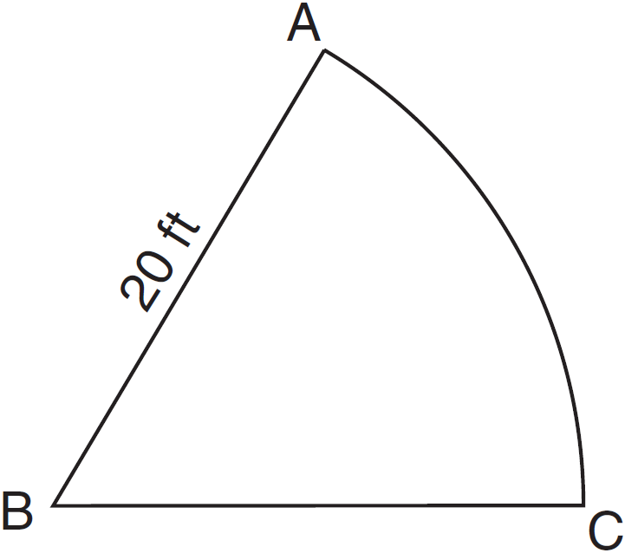

What is the length of arc AC, in feet?
1) | 63
2) | 31
3) | 20
4) | 10

2 A circle has a radius of 4 inches. In inches, what is the length of the arc intercepted by a central angle of 2 radians?
1)
2) | 2
3)
4) | 8

3 In a circle with a diameter of 24 cm, a central angle of radians intercepts an arc. The length of the arc, in centimeters, is
1)
2)
3)
4)

4 A wheel has a radius of 18 inches. Which distance, to the nearest inch, does the wheel travel when it rotates through an angle of radians?
1) | 45
2) | 23
3) | 13
4) | 11

5 Jack wants to plant a border of flowers in the shape of an arc along the edge of a circular walkway. If the circle has a radius of 5 yards and the angle subtended by the arc measures radians, what is the length, in yards, of the border?
1) | 0.5
2) | 2
3) | 5
4) | 7.5

6 A circle has a radius of 12 units. For this circle, which expression incorrectly states the length of the arc intercepted by the given central angle?
1) | 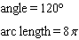
2) | 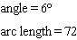
3) | 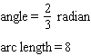
4) | 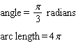

7 Circle O shown below has a radius of 12 centimeters. To the nearest tenth of a centimeter, determine the length of the arc, x, subtended by an angle of 83°50'.

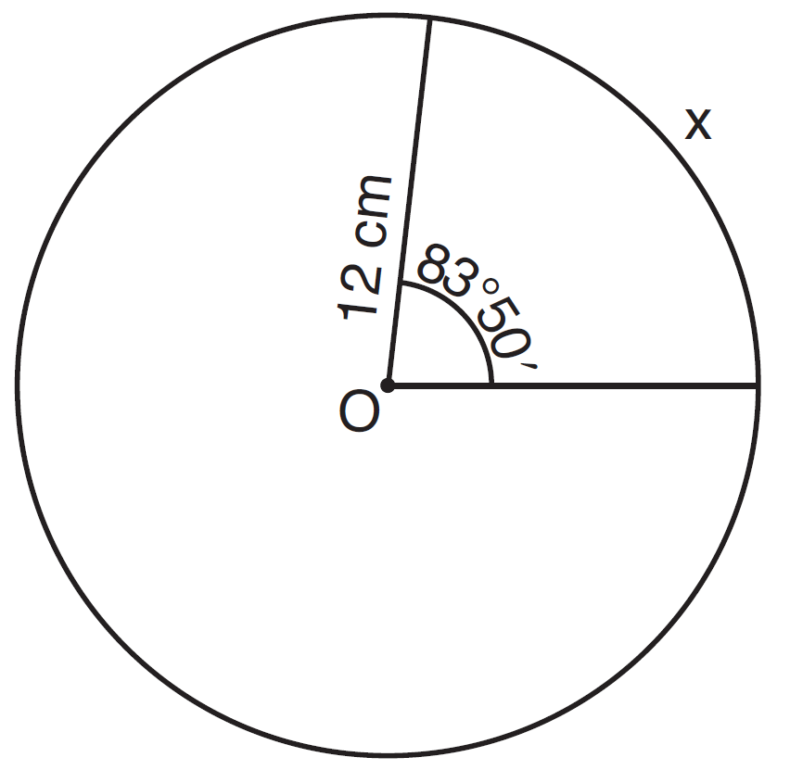

8 In the diagram below, Circle 1 has radius 4, while Circle 2 has radius 6.5. Angle A intercepts an arc of length , and angle B intercepts an arc of length .

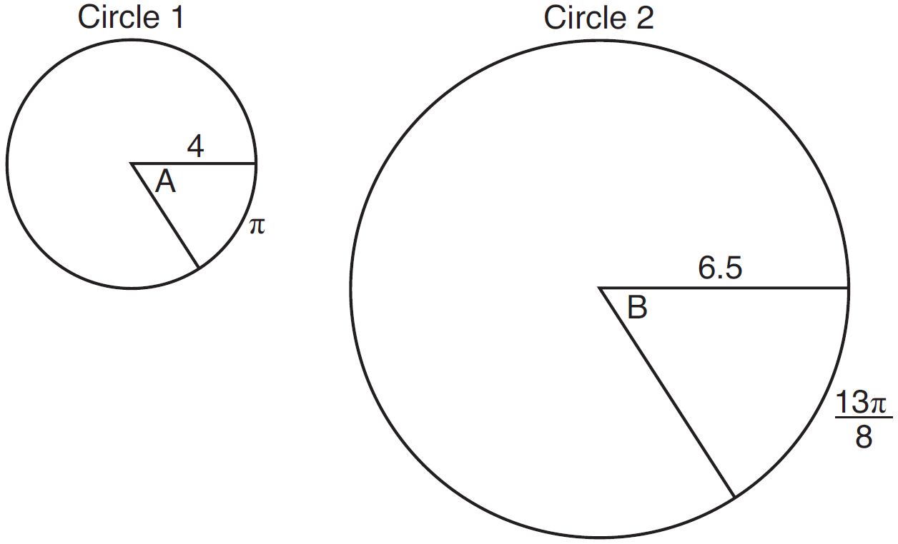

Dominic thinks that angles A and B have the same radian measure. State whether Dominic is correct or not. Explain why.

9 In a circle whose radius is 10, what is the length of the arc intercepted by a central angle of 4 radians?

10 In a circle with a radius of 3 centimeters, find, in centimeters, the length of an arc intercepted by a central angle of 2 radians.

11 In a circle of radius 8, find the length of the arc intercepted by a central angle of 1.5 radians.

12 Circle O has a radius of 10. Find the length of an arc subtended by a central angle measuring 1.5 radians.

13 Express, in terms of , the length of the arc intercepted by a central angle of radian in a circle with radius 30.
1 ANS: 3
REF: 060818b

2 ANS: 4
REF: fall0922a2

3 ANS: 3
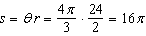
REF: 011611a2

4 ANS: 2
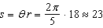
REF: 011526a2

5 ANS: 4
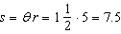.
REF: 010806b

6 ANS: 2
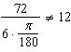
REF: 011722a2

7 ANS:

REF: 011435a2

8 ANS:
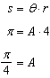 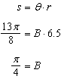 Yes, both angles are equal.
REF: 061629geo

9 ANS:
REF: 010415siii

10 ANS:
REF: 068514siii

11 ANS:
REF: 068713siii

12 ANS:
REF: 069714siii

13 ANS: 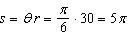
REF: 089313siii

