1 In circle O, the length of radius is 5 centimeters and the length of is 5 centimeters. The measure of is

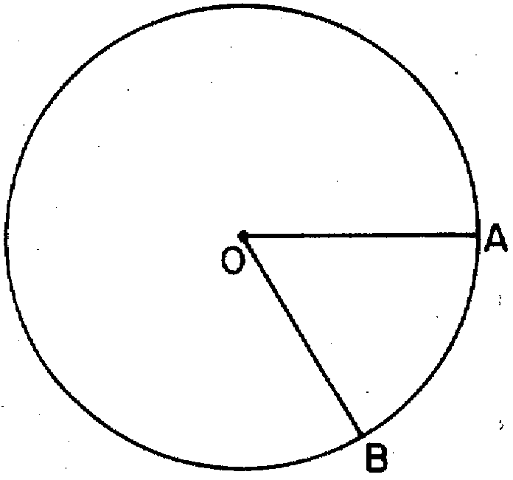
1) | 1 radian
2) | radians
3) | greater than 60°
4) | 60°

2 In the diagram below, the circle shown has radius 10. Angle B intercepts an arc with a length of .

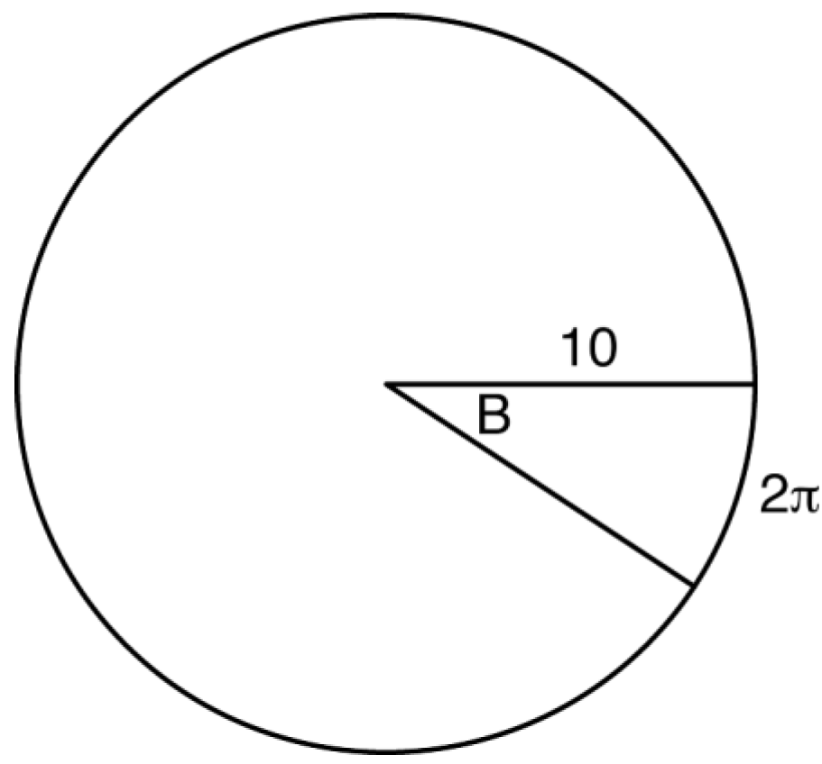

What is the measure of angle B, in radians?
1)
2)
3)
4)

3 A dog has a 20-foot leash attached to the corner where a garage and a fence meet, as shown in the accompanying diagram. When the dog pulls the leash tight and walks from the fence to the garage, the arc the leash makes is 55.8 feet.

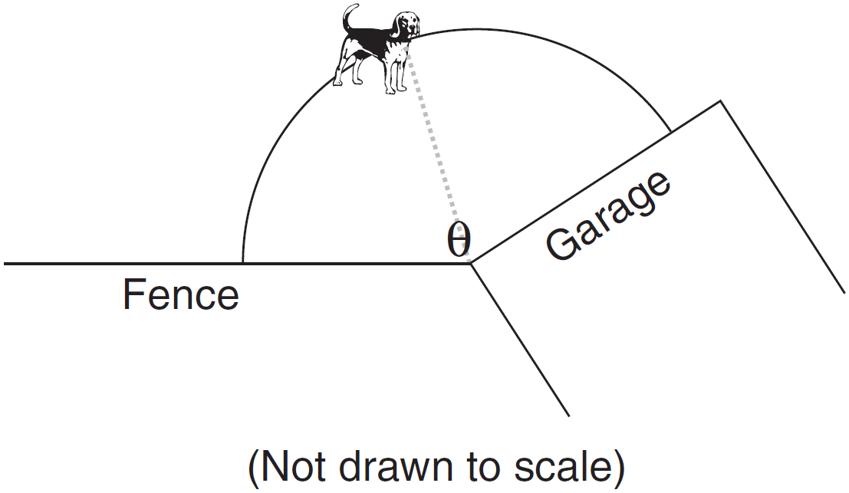

What is the measure of angle q between the garage and the fence, in radians?
1) | 0.36
2) | 2.79
3) | 3.14
4) | 160

4 What is the measure, in radians, of a central angle that intercepts an arc length of cm in a circle with a diameter of 36 cm?
1)
2)
3)
4)

5 A wedge-shaped piece is cut from a circular pizza. The radius of the pizza is 6 inches. The rounded edge of the crust of the piece measures 4.2 inches. To the nearest tenth, the angle of the pointed end of the piece of pizza, in radians, is
1) | 0.7
2) | 1.4
3) | 7.0
4) | 25.2

6 As shown in the accompanying diagram, a dial in the shape of a semicircle has a radius of 4 centimeters. Find the measure of θ, in radians, when the pointer rotates to form an arc whose length is 1.38 centimeters.

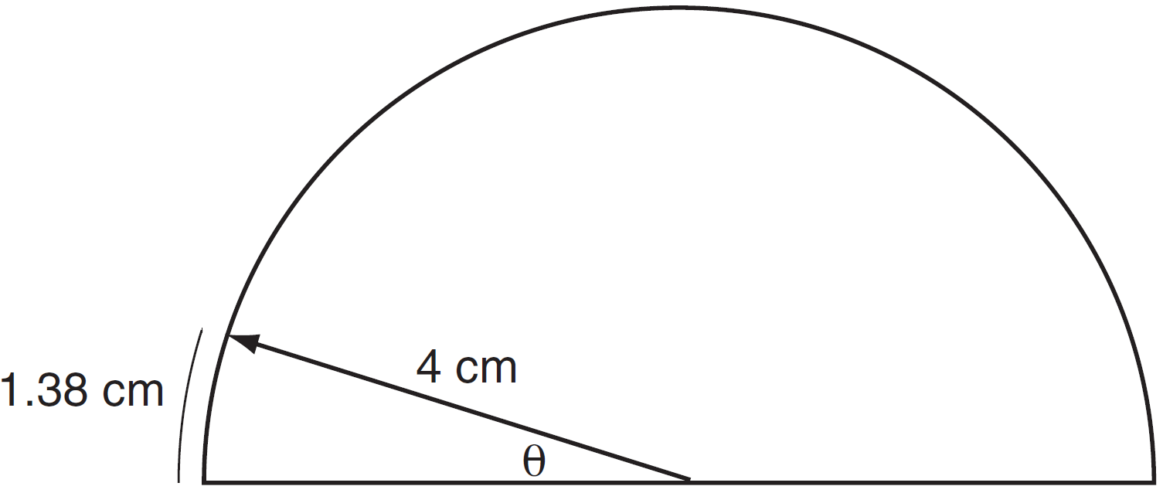

7 In a circle, a central angle intercepts an arc of 12 centimeters. If the radius of the circle is 6 centimeters, find the number of radians in the measure of the central angle.

8 An arc of a circle measures 30 centimeters and the radius measures 10 centimeters. In radians, what is the measure of the central angle that subtends the arc?

9 In a circle with a radius of 4 centimeters, what is the number of radians in the central angle that intercepts an arc of 8 centimeters?

10 In a circle whose radius is 9 centimeters, what is the number of radians in a central angle if the length of the intercepted arc is 18 centimeters?

11 In a circle whose radius is 2, a central angle intercepts an arc whose length is 6. What is the number of radians in the central angle of the arc?

12 In a circle with a radius of 4 centimeters, what is the number of radians in a central angle that intercepts an arc of 24 centimeters?

13 In a circle whose radius is 5 centimeters, a central angle intercepts an arc of 10 centimeters. What is the number of radians in the central angle?

14 In a circle with a diameter of 32, the area of a sector is 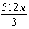. The measure of the angle of the sector, in radians, is
1)
2)
3)
4)

1 ANS: 1
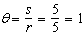

REF: 068422siii

2 ANS: 3
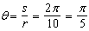

REF: fall1404geo

3 ANS: 2
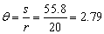

REF: 080309b

4 ANS: 3
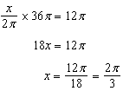

REF: 012520geo

5 ANS: 1
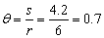

REF: 080116b

6 ANS:
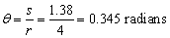

REF: 010725b

7 ANS:
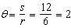

REF: 089508siii

8 ANS:
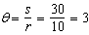

REF: 019615siii

9 ANS:
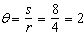

REF: 019713siii

10 ANS:
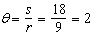

REF: 069811siii

11 ANS:
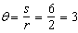

REF: 080108siii

12 ANS:
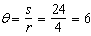

REF: 010207siii

13 ANS:
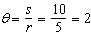

REF: 010316siii

14 ANS: 2
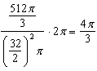

REF: 081723geo

