1 Given 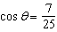, where is an angle in standard position terminating in quadrant IV, and , what is the value of ?
1) 2) 3) 4)

2 Given 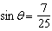 and terminates in quadrant II, what is the value of ?
1) 2) 3) 4)

3 If 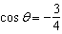 and is in Quadrant III, then is equivalent to
1) 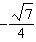 2) 3) 4)

4 Given that and 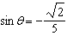, what is a possible value of ?
1) 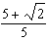 2) 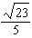 3) 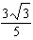 4) 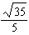

5 If 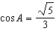 and , what is the value of ?
1) 2) 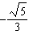 3) 4)

6 What is the value of when 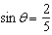 and is in quadrant II?
1) 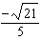 2) 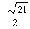 3) 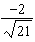 4) 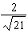

7 Given 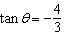 where 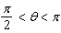, what is the value of ?
1) 2) 3) 4)

8 Using the identity , find the value of , to the nearest hundredth, if is –0.7 and is in Quadrant II.

9 Given 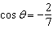 with in Quadrant II, find the exact value of .

10 Given 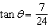, and terminates in Quadrant III, determine the value of .

11 Given 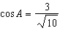 and , determine the value of in radical form.

1 ANS: 2
If , 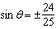, and 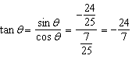

REF: 081811aii

2 ANS: 1
If , 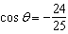 in QII, and 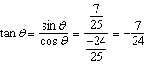

REF: 062417aii

3 ANS: 1
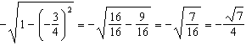

REF: 081905aii

4 ANS: 2
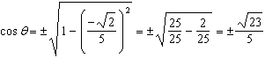

REF: 061712aii

5 ANS: 3
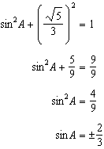 Since , 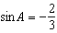

REF: 012320aii

6 ANS: 3
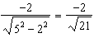

REF: 082312aii

7 ANS: 1
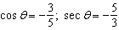

REF: 012421aii

8 ANS:
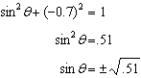 Since is in Quadrant II, and 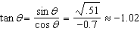

REF: 081628aii

9 ANS:
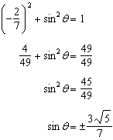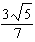 as sin is positive in Quadrant II.

REF: 012527aii

10 ANS:
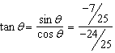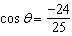

REF: 061928aii

11 ANS:
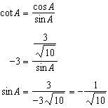

REF: 082229aii

