1 A regular pentagon is shown in the diagram below.
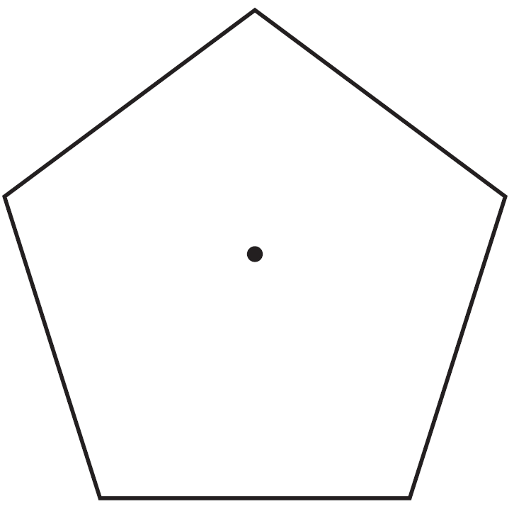
If the pentagon is rotated clockwise around its center, the minimum number of degrees it must be rotated to carry the pentagon onto itself is
1) | 54º
2) | 72º
3) | 108º
4) | 360º

2 The regular polygon below is rotated about its center.
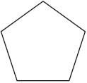
Which angle of rotation will carry the figure onto itself?
1) | 60°
2) | 108°
3) | 216°
4) | 540°

3 A regular pentagon is rotated about its center. What is the minimum number of degrees needed to carry the pentagon onto itself?
1) | 72°
2) | 108°
3) | 144°
4) | 360°

4 What is the minimum number of degrees that a regular hexagon must rotate about its center to carry it onto itself?
1) | 45°
2) | 72°
3) | 60°
4) | 120°

5 A regular hexagon is rotated about its center. Which degree measure will carry the regular hexagon onto itself?
1) | 45°
2) | 90°
3) | 120°
4) | 135°

6 A regular nonagon has a center point, P. What degree of rotation about point P will carry the nonagon onto itself?
1) | 60°
2) | 90°
3) | 180°
4) | 200°

7 Which rotation about its center will carry a regular decagon onto itself?
1) | 54°
2) | 162°
3) | 198°
4) | 252°

8 A regular decagon is rotated n degrees about its center, carrying the decagon onto itself. The value of n could be
1) | 10°
2) | 150°
3) | 225°
4) | 252°

9 Which polygon always has a minimum rotation of 180° about its center to carry it onto itself?
1) | 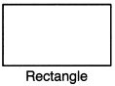
2) | 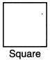
3) | 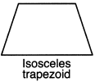
4) | 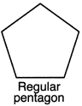

10 Which regular polygon has a minimum rotation of 36° about its center that carries the polygon onto itself?
1) | pentagon
2) | octagon
3) | nonagon
4) | decagon

11 Which regular polygon has a minimum rotation of 45° to carry the polygon onto itself?
1) | octagon
2) | decagon
3) | hexagon
4) | pentagon

12 Which regular polygon will carry onto itself after a 135° rotation about its center?
1) | triangle
2) | pentagon
3) | hexagon
4) | octagon

13 Which regular polygon would carry onto itself after a rotation of 300° about its center?
1) | decagon
2) | nonagon
3) | octagon
4) | hexagon

14 Which figure will not carry onto itself after a 120-degree rotation about its center?
1) | equilateral triangle
2) | regular hexagon
3) | regular octagon
4) | regular nonagon

15 Which figure always has exactly four lines of reflection that map the figure onto itself?
1) | square
2) | rectangle
3) | regular octagon
4) | equilateral triangle

16 A rhombus is graphed on the set of axes below.

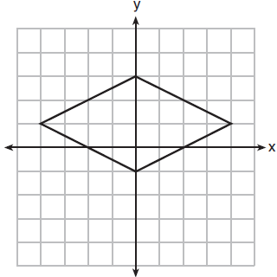

Which transformation would carry the rhombus onto itself?
1) | 180° rotation counterclockwise about the origin
2) | reflection over the line 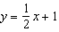
3) | reflection over the line
4) | reflection over the line

17 The figure below shows a rhombus with noncongruent diagonals.

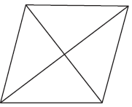

Which transformation would not carry this rhombus onto itself?
1) | a reflection over the shorter diagonal
2) | a reflection over the longer diagonal
3) | a clockwise rotation of 90° about the intersection of the diagonals
4) | a counterclockwise rotation of 180° about the intersection of the diagonals

18 In the diagram below, a square is graphed in the coordinate plane.
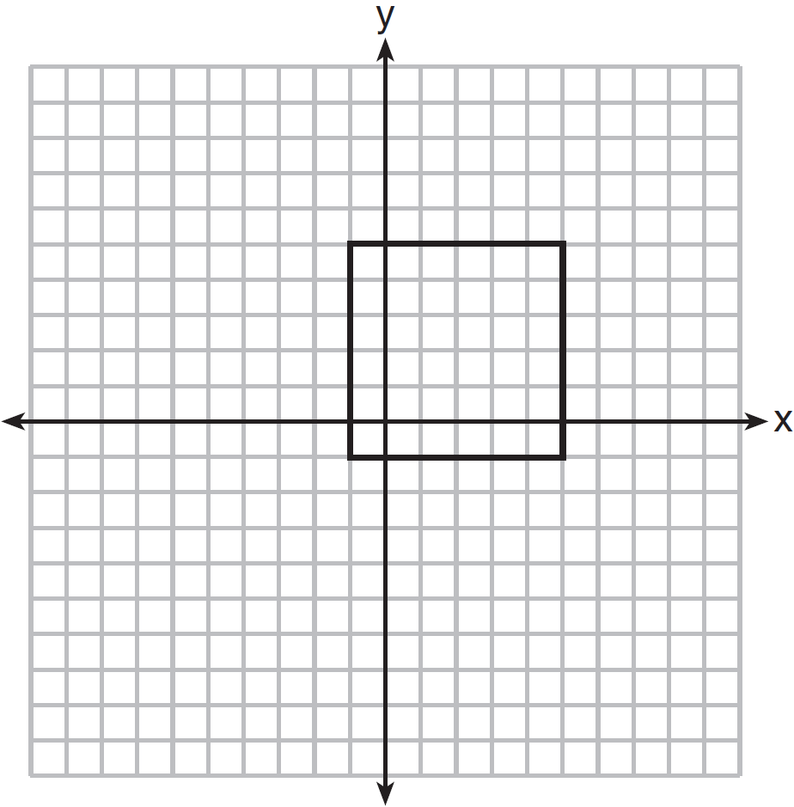
A reflection over which line does not carry the square onto itself?
1)
2)
3)
4)

19 In parallelogram ABCD below, diagonals and intersect at E.
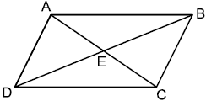
Which transformation would map onto ?
1) | a reflection over
2) | a reflection over
3) | a clockwise rotation of 90° about point E
4) | a clockwise rotation of 180° about point E

20 A rectangle is graphed on the set of axes below.
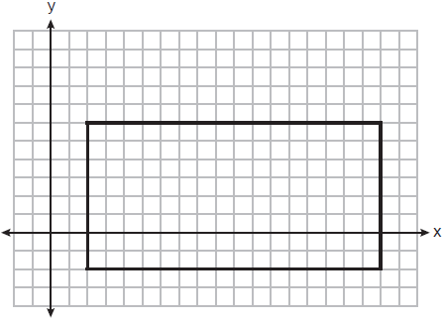
A reflection over which line would carry the rectangle onto itself?
1)
2)
3) | 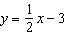
4) | 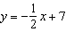

21 A square is graphed on the set of axes below, with vertices at , , , and .

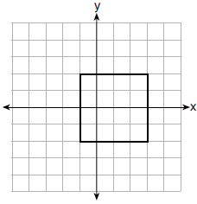

Which transformation would not carry the square onto itself?
1) | reflection over the y-axis
2) | reflection over the x-axis
3) | rotation of 180 degrees around point
4) | reflection over the line

22 As shown in the graph below, the quadrilateral is a rectangle.

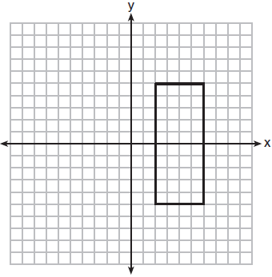

Which transformation would not map the rectangle onto itself?
1) | a reflection over the x-axis
2) | a reflection over the line
3) | a rotation of 180° about the origin
4) | a rotation of 180° about the point

23 In the diagram below, rectangle ABCD has vertices whose coordinates are , , , and .
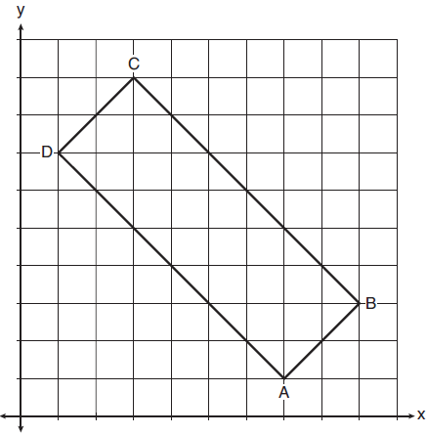
Which transformation will not carry the rectangle onto itself?
1) | a reflection over the line
2) | a reflection over the line
3) | a rotation of 180° about the point
4) | a rotation of 180° about the point

24 Which transformation carries the parallelogram below onto itself?

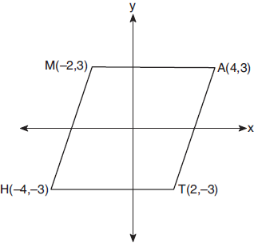
1) | a reflection over
2) | a reflection over
3) | a rotation of 90° counterclockwise about the origin
4) | a rotation of 180° counterclockwise about the origin

25 Which transformation would not carry a square onto itself?
1) | a reflection over one of its diagonals
2) | a 90° rotation clockwise about its center
3) | a 180° rotation about one of its vertices
4) | a reflection over the perpendicular bisector of one side

26 A regular hexagon is rotated in a counterclockwise direction about its center. Determine and state the minimum number of degrees in the rotation such that the hexagon will coincide with itself.
1 ANS: 2
Segments drawn from the center of the regular pentagon bisect each angle of the pentagon, and create five isosceles triangles as shown in the diagram below. Since each exterior angle equals the angles formed by the segments drawn from the center of the regular pentagon, the minimum degrees necessary to carry a regular polygon onto itself are equal to the measure of an exterior angle of the regular polygon.
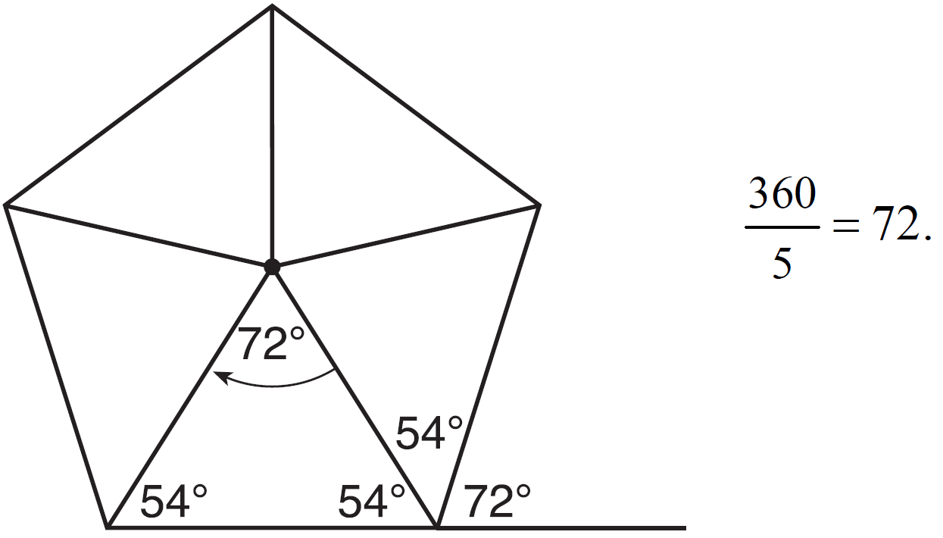

REF: spr1402geo

2 ANS: 3
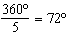 216º is a multiple of 72º

REF: 061819geo

3 ANS: 1

REF: 062204geo

4 ANS: 3
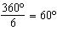

REF: 062403geo

5 ANS: 3
120º is a multiple of 60º

REF: 012011geo

6 ANS: 4
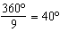 200º is a multiple of 40º

REF: 012521geo

7 ANS: 4
120º is a multiple of 60º

REF: 011717geo

8 ANS: 4
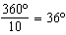 252º is a multiple of 36º

REF: 081722geo

9 ANS: 1
2) 90°; 3) 360°; 4) 72°

REF: 012311geo

10 ANS: 4
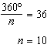

REF: 082205geo

11 ANS: 1
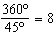

REF: 061510geo

12 ANS: 4
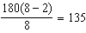

REF: 082415geo

13 ANS: 4
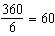 and 300 is a multiple of 60.

REF: 082306geo

14 ANS: 3
1) 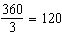; 2) ; 3) 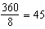; 4) 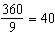. 120 is not a multiple of 45.

REF: 062320geo

15 ANS: 1 REF: 061707geo

16 ANS: 4 REF: 081923geo

17 ANS: 3 REF: 011904geo

18 ANS: 1 REF: 081505geo

19 ANS: 4 REF: 012515geo

20 ANS: 1 REF: 012403geo

21 ANS: 1 REF: 082209geo

22 ANS: 3
The x-axis and line are lines of symmetry and is a point of symmetry.

REF: 081706geo

23 ANS: 3 REF: 081817geo

24 ANS: 4 REF: 061904geo

25 ANS: 3 REF: 011815geo

26 ANS:

REF: 081627geo

