1 Triangle PQR is shown on the set of axes below.

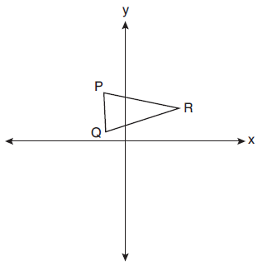

Which quadrant will contain point R", the image of point R, after a 90° clockwise rotation centered at followed by a reflection over the x-axis?
1) | I
2) | II
3) | III
4) | IV

2 On the set of axes below, triangle ABC is graphed. Triangles and , the images of triangle ABC, are graphed after a sequence of rigid motions.

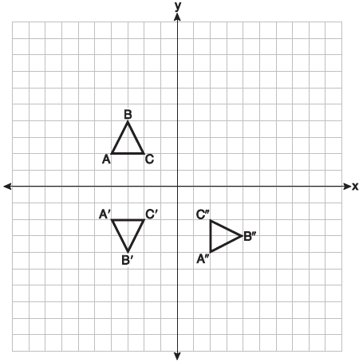

Identify which sequence of rigid motions maps onto and then maps onto .
1) | a rotation followed by another rotation
2) | a translation followed by a reflection
3) | a reflection followed by a translation
4) | a reflection followed by a rotation

3 Triangle ABC and triangle DEF are graphed on the set of axes below.
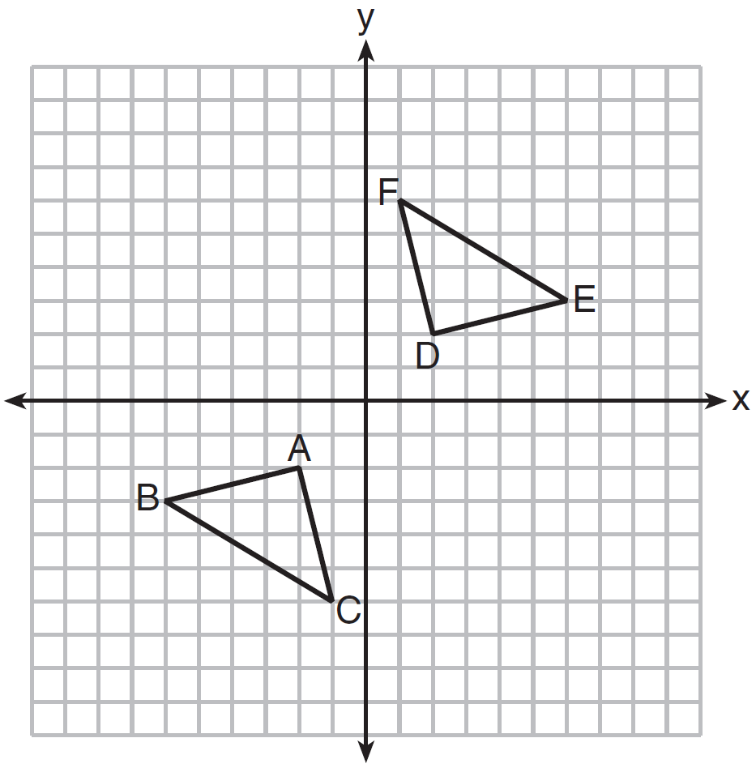
Which sequence of transformations maps triangle ABC onto triangle DEF?
1) | a reflection over the x-axis followed by a reflection over the y-axis
2) | a 180° rotation about the origin followed by a reflection over the line
3) | a 90° clockwise rotation about the origin followed by a reflection over the y-axis
4) | a translation 8 units to the right and 1 unit up followed by a 90° counterclockwise rotation about the origin

4 On the set of axes below, congruent triangles ABC and DEF are drawn.
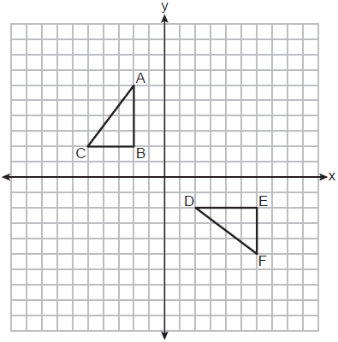
Which sequence of transformations maps onto ?
1) | A counterclockwise rotation of 90 degrees about the origin, followed by a translation 8 units to the right.
2) | A counterclockwise rotation of 90 degrees about the origin, followed by a reflection over the y-axis.
3) | A counterclockwise rotation of 90 degrees about the origin, followed by a translation 4 units down.
4) | A clockwise rotation of 90 degrees about the origin, followed by a reflection over the x-axis.

5 In the diagram below, .

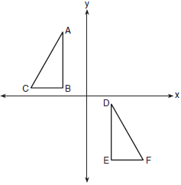

Which sequence of transformations maps onto ?
1) | a reflection over the x-axis followed by a translation
2) | a reflection over the y-axis followed by a translation
3) | a rotation of 180° about the origin followed by a translation
4) | a counterclockwise rotation of 90° about the origin followed by a translation

6 Triangles ABC and RST are graphed on the set of axes below.

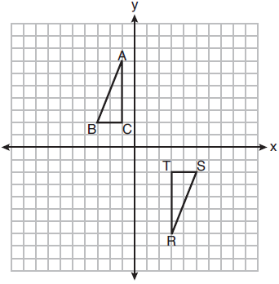

Which sequence of rigid motions will prove ?
1) | a line reflection over
2) | a rotation of 180° centered at
3) | a line reflection over the x-axis followed by a translation of 6 units right
4) | a line reflection over the x-axis followed by a line reflection over

7 On the set of axes below, and are graphed in the coordinate plane where .
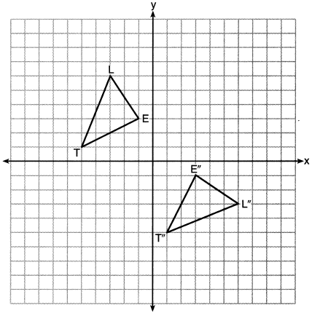

Which sequence of rigid motions maps onto ?
1) | a reflection over the y-axis followed by a reflection over the x-axis
2) | a rotation of 180° about the origin
3) | a rotation of 90° counterclockwise about the origin followed by a reflection over the y-axis
4) | a reflection over the x-axis followed by a rotation of 90° clockwise about the origin

8 In the diagram below, ABCD is a rectangle, and diagonal is drawn. Line , a vertical line of symmetry, and line m, a horizontal line of symmetry, intersect at point E.
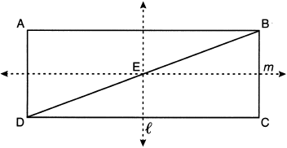

Which sequence of transformations will map onto ?
1) | a reflection over line followed by a 180° rotation about point E
2) | a reflection over line followed by a reflection over line m
3) | a 180° rotation about point B
4) | a reflection over

9 A sequence of transformations maps rectangle ABCD onto rectangle A"B"C"D", as shown in the diagram below.
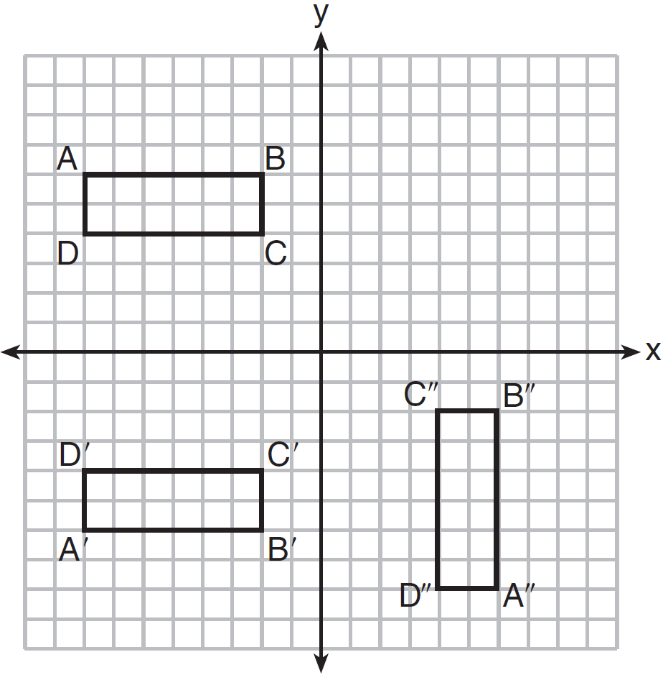

Which sequence of transformations maps ABCD onto A'B'C'D' and then maps A'B'C'D' onto A"B"C"D"?
1) | a reflection followed by a rotation
2) | a reflection followed by a translation
3) | a translation followed by a rotation
4) | a translation followed by a reflection

10 On the set of axes below, congruent parallelograms ABCD and RSTU are graphed.
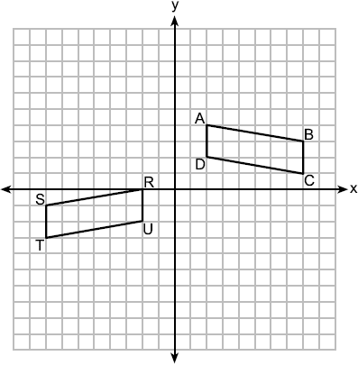

Which sequence of transformations maps ABCD onto RSTU?
1) | a reflection over the x-axis followed by a translation ten units to the left and one unit up
2) | a translation four units down followed by a reflection over the y-axis
3) | a reflection over the y-axis followed by a translation of two units down
4) | a translation ten units to the left followed by a reflection over the x-axis

11 Identify which sequence of transformations could map pentagon ABCDE onto pentagon A”B”C”D”E”, as shown below.

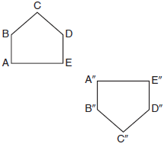
1) | dilation followed by a rotation
2) | translation followed by a rotation
3) | line reflection followed by a translation
4) | line reflection followed by a line reflection

12 On the set of axes below, pentagon ABCDE is congruent to A"B"C"D"E".

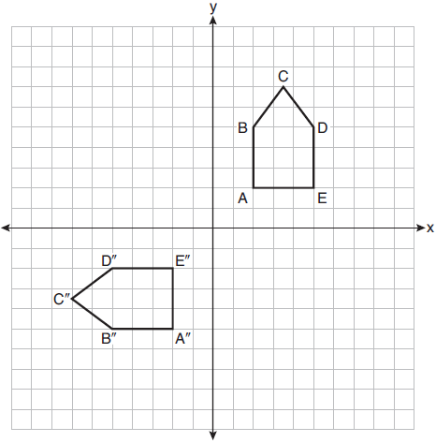

Which describes a sequence of rigid motions that maps ABCDE onto A"B"C"D"E"?
1) | a rotation of 90° counterclockwise about the origin followed by a reflection over the x-axis
2) | a rotation of 90° counterclockwise about the origin followed by a translation down 7 units
3) | a reflection over the y-axis followed by a reflection over the x-axis
4) | a reflection over the x-axis followed by a rotation of 90° counterclockwise about the origin

13 In the diagram below, congruent figures 1, 2, and 3 are drawn.

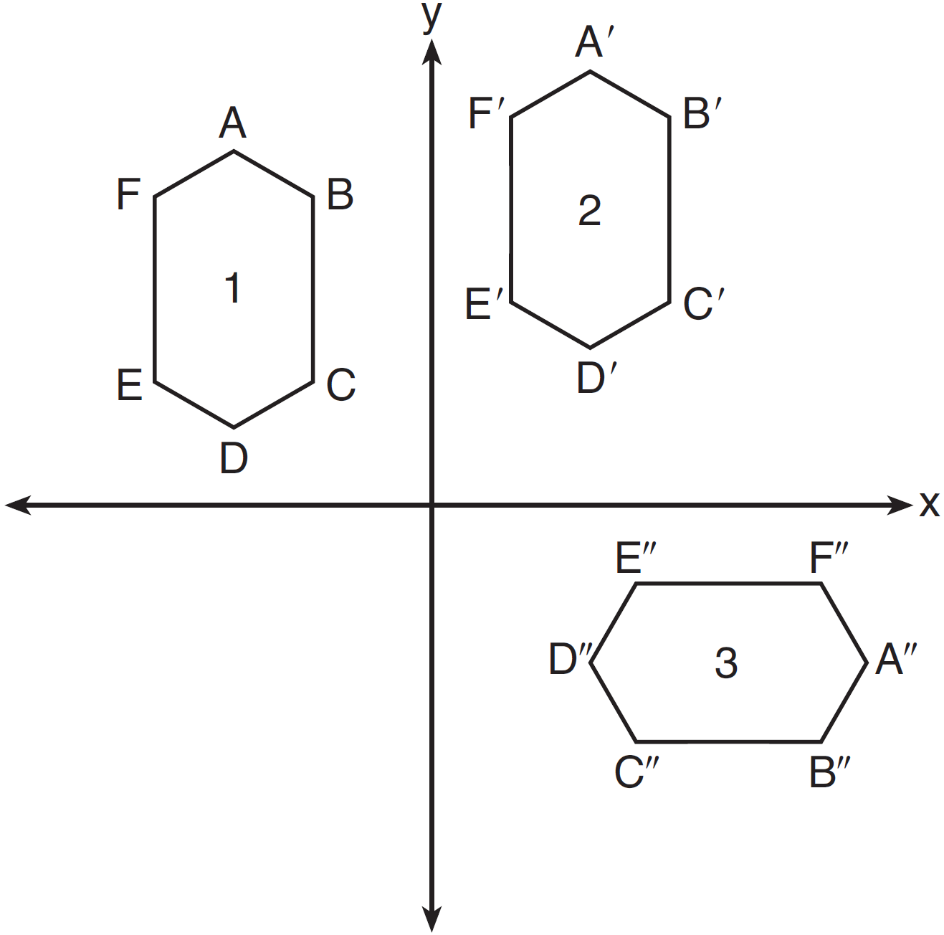

Which sequence of transformations maps figure 1 onto figure 2 and then figure 2 onto figure 3?
1) | a reflection followed by a translation
2) | a rotation followed by a translation
3) | a translation followed by a reflection
4) | a translation followed by a rotation

14 In regular hexagon ABCDEF shown below, , , and all intersect at G.

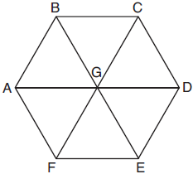

When is reflected over and then rotated 180° about point G, is mapped onto
1)
2)
3)
4)

1 ANS: 1 REF: 012022geo

2 ANS: 4 REF: 061901geo

3 ANS: 1 REF: 011608geo

4 ANS: 1 REF: 062308geo

5 ANS: 2 REF: 061701geo

6 ANS: 2 REF: 081909geo

7 ANS: 3
1) and 2) are wrong because the orientation of has changed, implying one reflection has occurred. The sequence in 4) moves back to Quadrant II.

REF: 062218geo

8 ANS: 2 REF: 082220geo

9 ANS: 1 REF: 081507geo

10 ANS: 2 REF: 012503geo

11 ANS: 3 REF: 011710geo

12 ANS: 2 REF: 012017geo

13 ANS: 4 REF: 061504geo

14 ANS: 1 REF: 081804geo

