1 If the circumference of a circle is doubled, the diameter of the circle
1) | remains the same
2) | increases by 2
3) | is multiplied by 4
4) | is doubled

2 What is the diameter of a circle whose circumference is 5?
1)
2)
3)
4)

3 What is the approximate circumference of a circle with radius 3?
1) | 7.07
2) | 9.42
3) | 18.85
4) | 28.27

4 The car tire shown in the photograph below has a diameter of feet.

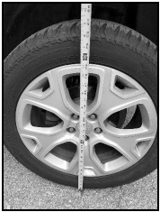

Approximately how many rotations will the tire make in one mile?
1) | 373
2) | 747
3) | 1328
4) | 2347

5 A circle with a radius of 5 was divided into 24 congruent sectors. The sectors were then rearranged, as shown in the diagram below.

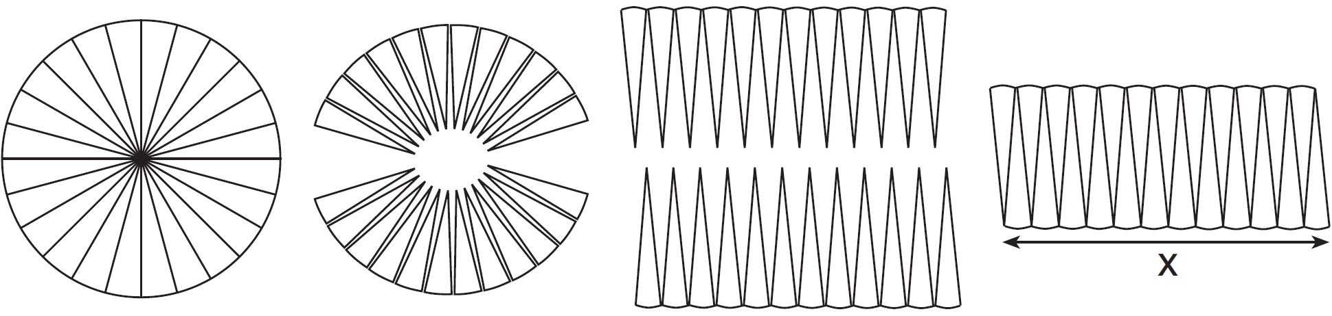

To the nearest integer, the value of x is
1) | 31
2) | 16
3) | 12
4) | 10

6 A designer needs to create perfectly circular necklaces. The necklaces each need to have a radius of 10 cm. What is the largest number of necklaces that can be made from 1000 cm of wire?
1) | 15
2) | 16
3) | 31
4) | 32

7 Every time the pedals go through a 360° rotation on a certain bicycle, the tires rotate three times. If the tires are 24 inches in diameter, what is the minimum number of complete rotations of the pedals needed for the bicycle to travel at least 1 mile?
1) | 12
2) | 281
3) | 561
4) | 5,280

8 A wheel has a radius of 5 feet. What is the minimum number of complete revolutions that the wheel must make to roll at least 1,000 feet?

9 To measure the length of a hiking trail, a worker uses a device with a 2-foot-diameter wheel that counts the number of revolutions the wheel makes. If the device reads 1,100.5 revolutions at the end of the trail, how many miles long is the trail, to the nearest tenth of a mile?
1 ANS: 4 REF: 060215a

2 ANS: 4
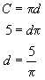

REF: 069914a

3 ANS: 3

REF: 080108a

4 ANS: 2
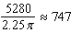

REF: 012523geo

5 ANS: 2
x is the circumference. 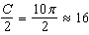

REF: 061523geo

6 ANS: 1
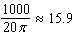

REF: 011623geo

7 ANS: 2
If the diameter of a tire is 2 feet, its circumference is 2π feet. To travel 1 mile, or 5280 feet, the tires must rotate 840.3 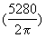 times. The pedals must rotate 281 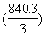 times.

REF: 010215b

8 ANS:
32. Circumference is 10π. 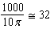

REF: 010437a

9 ANS:
1.3. . 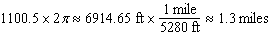

REF: 080027a

