1 If the length of a rectangular prism is doubled, its width is tripled, and its height remains the same, what is the volume of the new rectangular prism?
1) | double the original volume
2) | triple the original volume
3) | six times the original volume
4) | nine times the original volume

2 A box in the shape of a cube has a volume of 64 cubic inches. What is the length of a side of the box?
1) | in
2) | 16 in
3) | 8 in
4) | 4 in

3 A planned building was going to be 100 feet long, 75 feet deep, and 30 feet high. The owner decides to increase the volume of the building by 10% without changing the dimensions of the depth and the height. What will be the new length of this building?
1) | 106 ft
2) | 108 ft
3) | 110 ft
4) | 112 ft

4 A block of wood is 5 inches long, 2 inches wide, and 3 inches high. What is the volume of this block of wood?
1)
2)
3)
4)

5 If the length of a side of a cube is 7x, which expression represents the cube's volume?
1)
2)
3)
4)

6 Lenny made a cube in technology class. Each edge measured 1.5 cm. What is the volume of the cube in cubic centimeters?
1) | 2.25
2) | 3.375
3) | 9.0
4) | 13.5

7 How many cubes with 5-inch sides will completely fill a cube that is 10 inches on a side?
1) | 50
2) | 25
3) | 8
4) | 4

8 A rectangular tank measures 5 feet long, 4 feet wide, and 3 feet high. Water is poured into the tank to a depth of feet. How many cubic feet of water are in the tank?
1) | 60
2) | 50
3) | 15.5
4) | 11.5

9 A fish tank with a rectangular base has a volume of 3,360 cubic inches. The length and width of the tank are 14 inches and 12 inches, respectively. Find the height, in inches, of the tank.

10 The dimensions of a brick, in inches, are 2 by 4 by 8. How many such bricks are needed to have a total volume of exactly 1 cubic foot?

11 The volume of a rectangular pool is 1,080 cubic meters. Its length, width, and depth are in the ratio . Find the number of meters in each of the three dimensions of the pool.

12 Jed bought a generator that will run for 2 hours on a liter of gas. The gas tank on the generator is a rectangular prism with dimensions 20 cm by 15 cm by 10 cm as shown below.

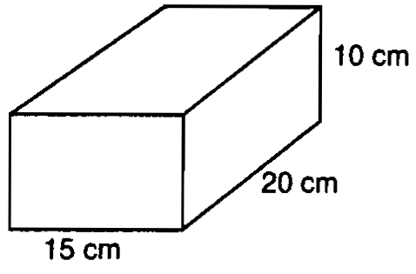

If Jed fills the tank with gas, how long will the generator run? Show how you arrived at your answer. [Note: 1000 cm³ = 1 liter]

13 Deborah built a box by cutting 3-inch squares from the corners of a rectangular sheet of cardboard, as shown in the accompanying diagram, and then folding the sides up. The volume of the box is 150 cubic inches, and the longer side of the box is 5 inches more than the shorter side. Find the number of inches in the shorter side of the original sheet of cardboard.

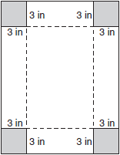

14 A rectangular prism has a length of 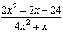, a width of 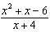, and a height of 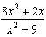. For all values of x for which it is defined, express, in terms of x, the volume of the prism in simplest form.

15 A cardboard box has length , width , and height .
a Write an expression, in terms of x, to represent the volume of the box.
b If centimeters, what is the number of cubic centimeters in the volume of the box?

16 Tina’s preschool has a set of cardboard building blocks, each of which measures 9 inches by 9 inches by 4 inches. How many of these blocks will Tina need to build a wall 4 inches thick, 3 feet high, and 12 feet long?

17 As shown in the accompanying diagram, the length, width, and height of Richard’s fish tank are 24 inches, 16 inches, and 18 inches, respectively. Richard is filling his fish tank with water from a hose at the rate of 500 cubic inches per minute. How long will it take, to the nearest minute, to fill the tank to a depth of 15 inches?

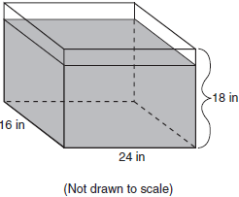

18 Tracey has two empty cube-shaped containers with sides of 5 inches and 7 inches, as shown in the accompanying diagram. She fills the smaller container completely with water and then pours all the water from the smaller container into the larger container. How deep, to the nearest tenth of an inch, will the water be in the larger container?

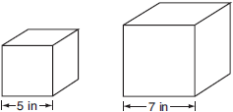

19 The diagram below represents Joe's two fish tanks.

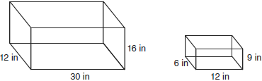

Joe's larger tank is completely filled with water. He takes water from it to completely fill the small tank. Determine how many cubic inches of water will remain in the larger tank.

20 A particular jewelry box is in the shape of a rectangular prism. The box is advertised as having an interior length of 20.3 centimeters, an interior width of 12. 7 centimeters, and an interior height of 10.2 centimeters. However, when a customer measures the interior of the box, she finds that the interior height is actually 6.3 centimeters. Upon further examination, she discovers that the bottom of the interior of the box lifts up to reveal a hidden compartment. Find the volume of this hidden compartment to the nearest cubic centimeter.
1 ANS: 3
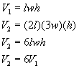
REF: 060103a

2 ANS: 4
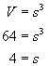
REF: 060427a

3 ANS: 3
REF: 010711a

4 ANS: 3
REF: 010802a

5 ANS: 4
REF: 060830a

6 ANS: 2
REF: 060809ia

7 ANS: 3
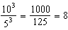
REF: 011312ia

8 ANS: 2
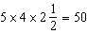
REF: 061530ia

9 ANS:
20. 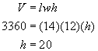
REF: 010324a

10 ANS:
27. 1 cubic foot equals or 1728 cubic inches. 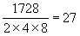 bricks
REF: 069927a

11 ANS:
3, 12, 30. 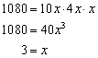. 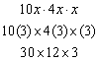
REF: 010030a

12 ANS:
6 hours. . If the generator runs for 2 hours on 1 liter, the generator will run for 6 hours on 3 liters.
REF: spring9832a

13 ANS:
11. 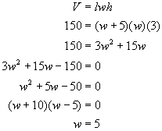. Reject as negative width. If the width of the box is 5, adding the widths of the cutout squares means the width of the original sheet of cardboard is 11 (5 + 3 + 3).
REF: 060331a

14 ANS:
.
REF: 060124b

15 ANS:
, 864.
REF: 010123a

16 ANS:
64. The wall in common dimensions is 4 by 36 by 144 inches, with a volume of 20736 cubic inches. The volume of a block is 324 cubic inches. 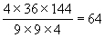
REF: 060327a

17 ANS:
12. 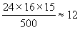
REF: 010537a

18 ANS:
2.6. If Tracey fills the smaller container, it will contain cubic inches of water. 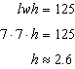
REF: 060737a

19 ANS:
5,112.

REF: 080932ia

20 ANS:

REF: 061635ia

