1 The diagram below models a countertop designed for a kitchen. The countertop is made of solid oak and is 3 inches thick.
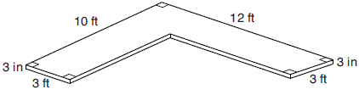

If oak weighs approximately 44 pounds per cubic foot, the approximate weight, in pounds, of the countertop is
1) | 630 | 3) | 750
2) | 730 | 4) | 870

2 A fabricator is hired to make a 27-foot-long solid metal railing for the stairs at the local library. The railing is modeled by the diagram below. The railing is 2.5 inches high and 2.5 inches wide and is comprised of a rectangular prism and a half-cylinder.
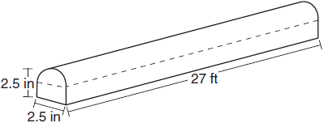

How much metal, to the nearest cubic inch, will the railing contain?
1) | 151 | 3) | 1808
2) | 795 | 4) | 2025

3 The greenhouse pictured below can be modeled as a rectangular prism with a half-cylinder on top. The rectangular prism is 20 feet wide, 12 feet high, and 45 feet long. The half-cylinder has a diameter of 20 feet.
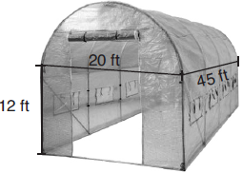

To the nearest cubic foot, what is the volume of the greenhouse?
1) | 17,869 | 3) | 39,074
2) | 24,937 | 4) | 67,349

4 A storage building is modeled below by a hemisphere on top of a cylinder. The diameter of both the cylinder and hemisphere is 12 feet. The total height of the storage building is 30 feet.

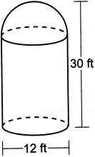

To the nearest cubic foot, what is the volume of the storage building?
1) | 942 | 3) | 3167
2) | 2488 | 4) | 3845

5 A vendor is using an 8-ft by 8-ft tent for a craft fair. The legs of the tent are 9 ft tall and the top forms a square pyramid with a height of 3 ft.

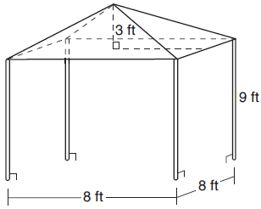

What is the volume, in cubic feet, of space the tent occupies?
1) | 256 | 3) | 672
2) | 640 | 4) | 768

6 A solid metal prism has a rectangular base with sides of 4 inches and 6 inches, and a height of 4 inches. A hole in the shape of a cylinder, with a radius of 1 inch, is drilled through the entire length of the rectangular prism.

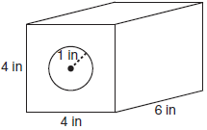

What is the approximate volume of the remaining solid, in cubic inches?
1) | 19 | 3) | 93
2) | 77 | 4) | 96

7 A company is creating an object from a wooden cube with an edge length of 8.5 cm. A right circular cone with a diameter of 8 cm and an altitude of 8 cm will be cut out of the cube. Which expression represents the volume of the remaining wood?
1) |  | 3) | 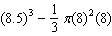
2) |  | 4) | 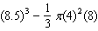

8 Josh is making a square-based fire pit out of concrete for his backyard, as modeled by the right prism below. He plans to make the outside walls of the fire pit 3.5 feet on each side with a height of 1.5 feet. The concrete walls of the fire pit are going to be 9 inches thick.

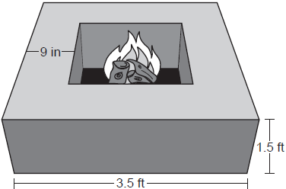

If a bag of concrete mix will fill 0.6 ft³, determine and state the minimum number of bags needed to build the fire pit.

9 A garden bed, pictured below, is a square prism with a rectangular prism taken out. The inside length of the square prism is 6 feet. The rectangular prism taken out has a width of 2 feet and a length of 4 feet. The diagram below shows the top view of the garden bed with its inside measurements.

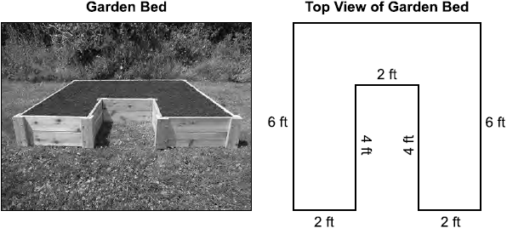

The garden bed is filled with topsoil to a uniform height of 1.25 feet. Determine and state the volume of the topsoil, in cubic feet. Each bag of topsoil sells for $3.68 and contains 2 cubic feet of topsoil. Determine and state the total cost of the bags of topsoil that must be purchased to fill the garden.

10 A cargo trailer, pictured below, can be modeled by a rectangular prism and a triangular prism. Inside the trailer, the rectangular prism measures 6 feet wide and 10 feet long. The walls that form the triangular prism each measure 4 feet wide inside the trailer. The diagram below is of the floor, showing the inside measurements of the trailer.

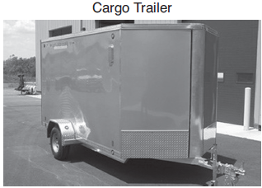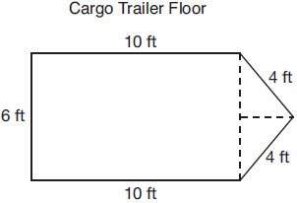

If the inside height of the trailer is 6.5 feet, what is the total volume of the inside of the trailer, to the nearest cubic foot?

11 A building is composed of a rectangular pyramid on top of a rectangular prism, as shown in the diagram below. The rectangular prism has a length of 38 feet, a width of 15 feet, and a height of 22 feet. The rectangular pyramid sits directly on top of the rectangular prism, and its height is 12 feet.

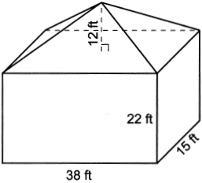

An air purification filter was installed that will clean all the air in the building at a rate of 2400 cubic feet per minute. Determine and state how long it will take, to the nearest tenth of a minute, for the filter to clean the air contained in the building.

12 A storage tank is in the shape of a cylinder with a hemisphere on the top. The highest point on the inside of the storage tank is 13 meters above the floor of the storage tank, and the diameter inside the cylinder is 8 meters. Determine and state, to the nearest cubic meter, the total volume inside the storage tank.

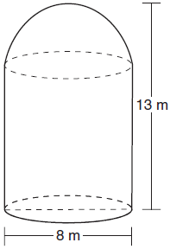

13 A rectangular in-ground pool is modeled by the prism below. The inside of the pool is 16 feet wide and 35 feet long. The pool has a shallow end and a deep end, with a sloped floor connecting the two ends. Without water, the shallow end is 9 feet long and 4.5 feet deep, and the deep end of the pool is 12.5 feet long.

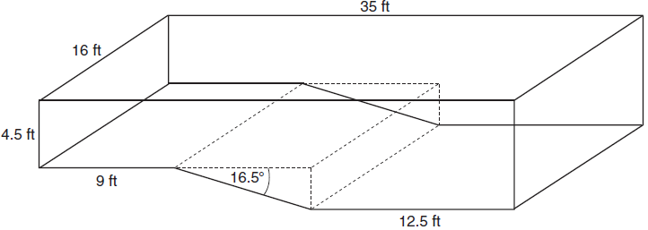

If the sloped floor has an angle of depression of 16.5 degrees, what is the depth of the pool at the deep end, to the nearest tenth of a foot? Find the volume of the inside of the pool to the nearest cubic foot. A garden hose is used to fill the pool. Water comes out of the hose at a rate of 10 .5 gallons per minute. How much time, to the nearest hour, will it take to fill the pool 6 inches from the top? [1 ft³=7.48 gallons]
1 ANS: 1
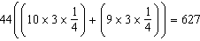

REF: 082221geo

2 ANS: 3
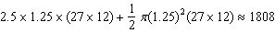

REF: 061723geo

3 ANS: 1
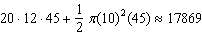

REF: 061807geo

4 ANS: 3
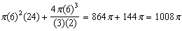

REF: 082414geo

5 ANS: 2
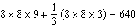

REF: 011909geo

6 ANS: 2

REF: 011711geo

7 ANS: 4 REF: 061606geo

8 ANS:
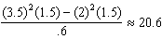. 21 bags

REF: 082332geo

9 ANS:

REF: 012533geo

10 ANS:
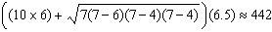

REF: 081934geo

11 ANS:
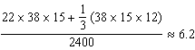

REF: 062432geo

12 ANS:
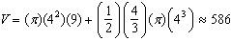

REF: 011833geo

13 ANS:
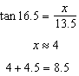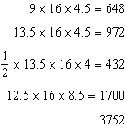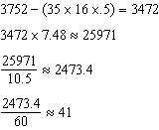

REF: 081736geo

