1 A student has a rectangular postcard that he folds in half lengthwise. Next, he rotates it continuously about the folded edge. Which three-dimensional object below is generated by this rotation?
1) | 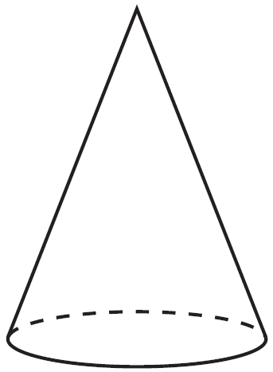
2) | 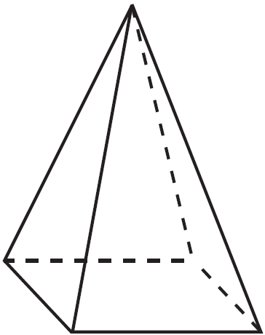
3) | 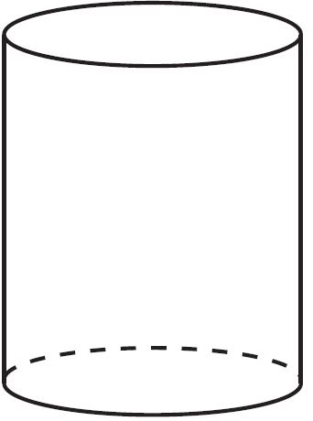
4) | 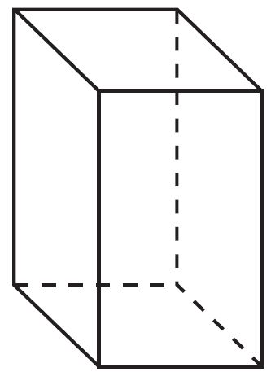

2 If the rectangle below is continuously rotated about side w, which solid figure is formed?

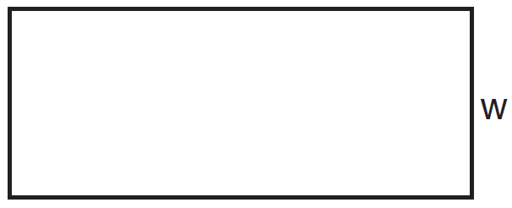
1) | pyramid
2) | rectangular prism
3) | cone
4) | cylinder

3 The rectangle drawn below is continuously rotated about side S.

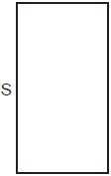

Which three-dimensional figure is formed by this rotation?
1) | rectangular prism
2) | square pyramid
3) | cylinder
4) | cone

4 Which object is formed when right triangle RST shown below is rotated around leg ?

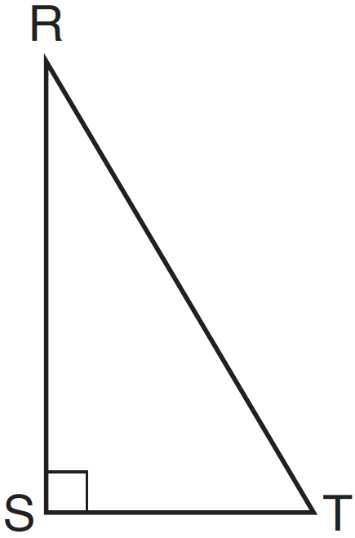
1) | a pyramid with a square base
2) | an isosceles triangle
3) | a right triangle
4) | a cone

5 Triangle ABC represents a metal flag on pole AD, as shown in the accompanying diagram. On a windy day the triangle spins around the pole so fast that it looks like a three-dimensional shape.

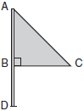

Which shape would the spinning flag create?
1) | sphere
2) | pyramid
3) | right circular cylinder
4) | cone

6 Circle O is centered at the origin. In the diagram below, a quarter of circle O is graphed.

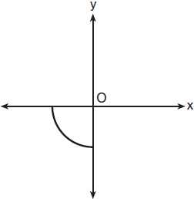

Which three-dimensional figure is generated when the quarter circle is continuously rotated about the y-axis?
1) | cone
2) | sphere
3) | cylinder
4) | hemisphere

7 If a rectangle is continuously rotated around one of its sides, what is the three-dimensional figure formed?
1) | rectangular prism
2) | cylinder
3) | sphere
4) | cone

8 If an equilateral triangle is continuously rotated around one of its medians, which 3-dimensional object is generated?
1) | cone
2) | pyramid
3) | prism
4) | sphere

9 A circle is continuously rotated about its diameter. Which threedimensional object will be formed?
1) | cone
2) | prism
3) | sphere
4) | cylinder

10 As shown in the diagram below, right triangle ABC has side lengths of 8 and 15.

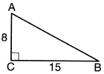

If the triangle is continuously rotated about , the resulting figure will be
1) | a right cone with a radius of 15 and a height of 8
2) | a right cone with a radius of 8 and a height of 15
3) | a right cylinder with a radius of 15 and a height of 8
4) | a right cylinder with a radius of 8 and a height of 15

11 An isosceles right triangle whose legs measure 6 is continuously rotated about one of its legs to form a three-dimensional object. The three-dimensional object is a
1) | cylinder with a diameter of 6
2) | cylinder with a diameter of 12
3) | cone with a diameter of 6
4) | cone with a diameter of 12

12 Square MATH has a side length of 7 inches. Which three-dimensional object will be formed by continuously rotating square MATH around side ?
1) | a right cone with a base diameter of 7 inches
2) | a right cylinder with a diameter of 7 inches
3) | a right cone with a base radius of 7 inches
4) | a right cylinder with a radius of 7 inches

13 A rectangle with dimensions of 4 feet by 7 feet is continuously rotated about one of its 4-foot sides. The resulting three-dimensional object is a
1) | cylinder with a height of 7 feet and a base radius of 4 feet.
2) | cylinder with a height of 4 feet and a base radius of 7 feet.
3) | cone with a height of 7 feet and a base radius of 7 feet.
4) | cone with a height of 4 feet and a base radius of 7 feet.

14 Which three-dimensional figure will result when a rectangle 6 inches long and 5 inches wide is continuously rotated about the longer side?
1) | a rectangular prism with a length of 6 inches, width of 6 inches, and height of 5 inches
2) | a rectangular prism with a length of 6 inches, width of 5 inches, and height of 5 inches
3) | a cylinder with a radius of 5 inches and a height of 6 inches
4) | a cylinder with a radius of 6 inches and a height of 5 inches

15 A square with a side length of 3 is continuously rotated about one of its sides. The resulting three-dimensional object is a
1) | cube with a volume of 9.
2) | cube with a volume of 27.
3) | cylinder with a volume of 27.
4) | cylinder with a volume of 54.

16 In the diagram below, right triangle ABC has legs whose lengths are 4 and 6.

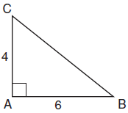

What is the volume of the three-dimensional object formed by continuously rotating the right triangle around ?
1) | 32π
2) | 48π
3) | 96π
4) | 144π

17 A rectangle whose length and width are 10 and 6, respectively, is shown below. The rectangle is continuously rotated around a straight line to form an object whose volume is .

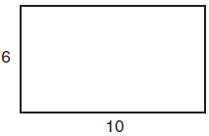

Which line could the rectangle be rotated around?
1) | a long side
2) | a short side
3) | the vertical line of symmetry
4) | the horizontal line of symmetry

18 Triangle ABC, with vertices at , , and , is graphed on the set of axes shown below.

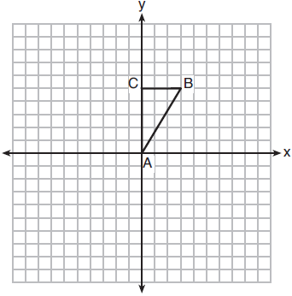

Which figure is formed when is rotated continuously about ?
1) | 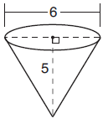
2) | 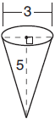
3) | 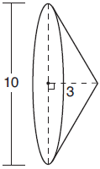
4) | 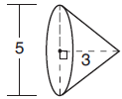

19 In right triangle MTH shown below, , , and .

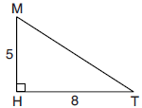

Determine and state, to the nearest tenth, the volume of the three-dimensional solid formed by rotating continuously around .

20 In isosceles triangle ABC shown below, , and altitude is drawn.

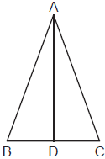

The length of is 12 cm and the length of is 10 cm. Determine and state, to the nearest cubic centimeter, the volume of the solid formed by continuously rotating about .
1 ANS: 3 REF: 061601geo

2 ANS: 4 REF: 081503geo

3 ANS: 3 REF: 082307geo

4 ANS: 4 REF: 061501geo

5 ANS: 4 REF: 010417a

6 ANS: 4 REF: 011810geo

7 ANS: 2 REF: 061903geo

8 ANS: 1 REF: 081603geo

9 ANS: 3 REF: 012302geo

10 ANS: 1 REF: 062208geo

11 ANS: 4 REF: 081803geo

12 ANS: 4 REF: 081911geo

13 ANS: 2 REF: 062415geo

14 ANS: 3 REF: 011911geo

15 ANS: 3

REF: 012507geo

16 ANS: 1
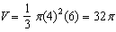

REF: 061718geo

17 ANS: 3
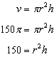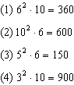

REF: 081713geo

18 ANS: 3 REF: 061816geo

19 ANS:
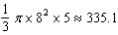

REF: 082226geo

20 ANS:
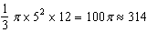

REF: 012425geo

