1 A three-inch line segment is dilated by a scale factor of 6 and centered at its midpoint. What is the length of its image?
1) | 9 inches
2) | 2 inches
3) | 15 inches
4) | 18 inches

2 Line segment , whose endpoints are and , is the image of after a dilation of centered at the origin. What is the length of ?
1) | 5
2) | 10
3) | 20
4) | 40

3 In the diagram below, is the image of after a dilation of scale factor k with center E.

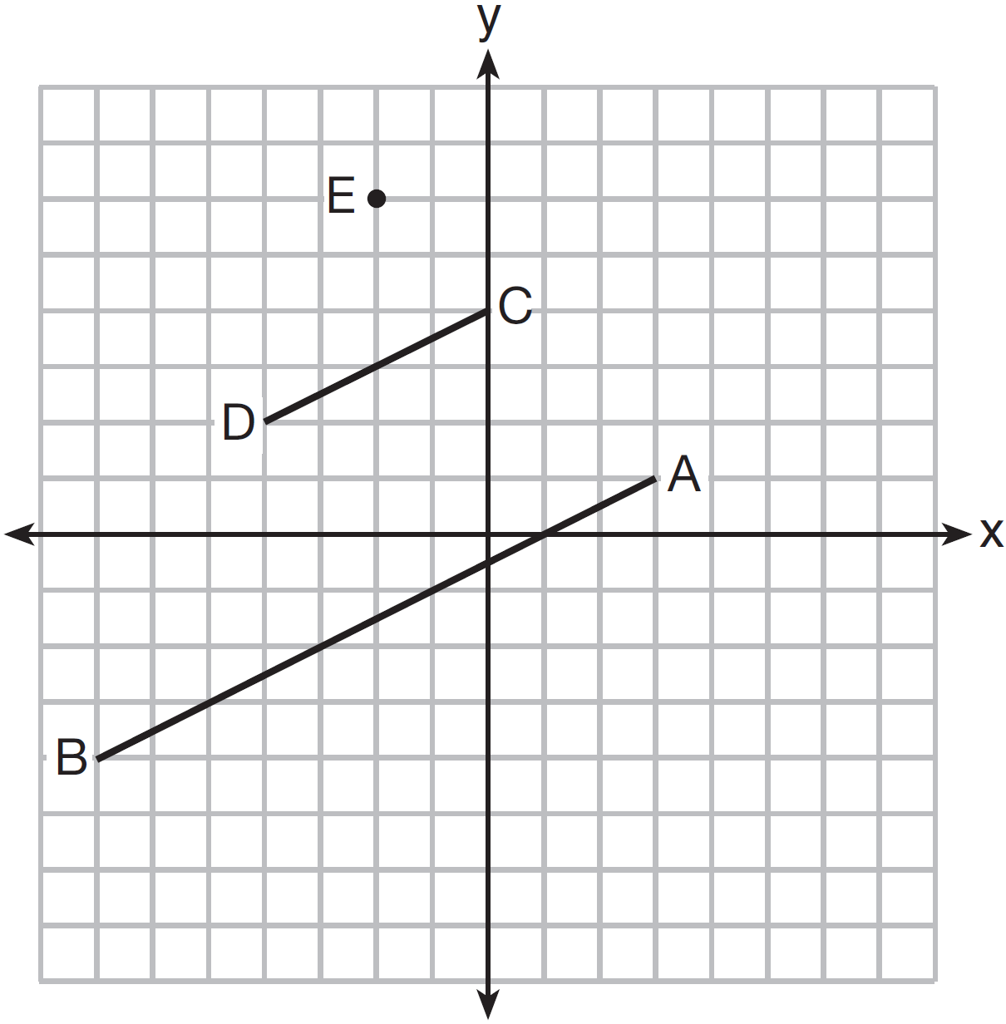

Which ratio is equal to the scale factor k of the dilation?
1)
2)
3)
4)

4 After a dilation centered at the origin, the image of is . If the coordinates of the endpoints of these segments are , , , and , the scale factor of the dilation is
1)
2)
3) | 3
4)

5 After a dilation with center , the image of is . If and , the scale factor of this dilation is
1)
2) | 5
3)
4) | 4

6 The line represented by is dilated by a scale factor of k centered at the origin, such that the image of the line has an equation of 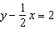. What is the scale factor?
1) | 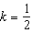
2)
3) | 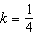
4)

7 On the set of axes below, , , , , and are drawn.
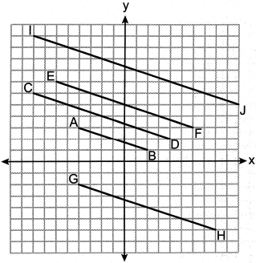
Which segment is the image of after a dilation with a scale factor of 2 centered at ?
1)
2)
3)
4)

8 On the graph below, point and with coordinates and are graphed.

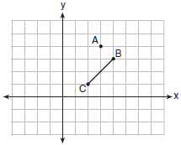

What are the coordinates of B’ and C’ after undergoes a dilation centered at point A with a scale factor of 2?
1) | and
2) | and
3) | and
4) | and

9 On the set of axes below, the endpoints of have coordinates and .

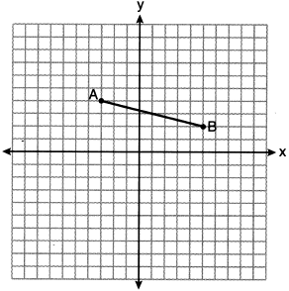

If is dilated by a scale factor of 2 centered at , what are the coordinates of the endpoints of its image, ?
1) | and
2) | and
3) | and
4) | and

10 On the set of axes below, is drawn and passes through and .

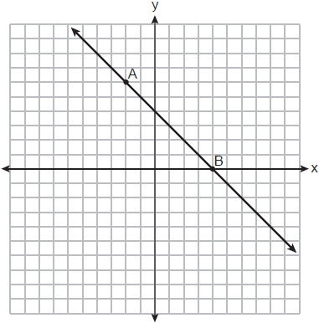

If is the image of after a dilation with a scale factor of centered at the origin, which equation represents ?
1)
2)
3) | 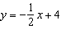
4) | 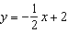

11 The line represented by the equation is dilated by a scale factor of 2 centered at the origin. Which equation represents its image?
1)
2)
3)
4)

12 The equation of line h is . Line m is the image of line h after a dilation of scale factor 4 with respect to the origin. What is the equation of the line m?
1)
2)
3)
4)

13 Line m, whose equation is , is dilated by a scale factor of centered at the origin. Which equation represents the image of line m?
1)
2)
3)
4)

14 The equation of line t is . Line m is the image of line t after a dilation with a scale factor of centered at the origin. What is an equation of the line m?
1) | 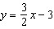
2) | 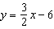
3)
4)

15 The line is dilated by a scale factor of and centered at the origin. Which equation represents the image of the line after the dilation?
1)
2)
3)
4)

16 What is an equation of the image of the line 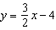 after a dilation of a scale factor of centered at the origin?
1) | 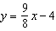
2) | 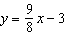
3)
4)

17 The line whose equation is is dilated by a scale factor of 2 centered at the point . An equation of its image is
1)
2)
3)
4)

18 Line is transformed by a dilation with a scale factor of 2 and centered at . The line's image is
1)
2)
3)
4)

19 Line MN is dilated by a scale factor of 2 centered at the point . If is represented by , which equation can represent , the image of ?
1)
2)
3)
4)

20 A line whose equation is is dilated by a scale factor of 4 centered at . Which equation represents the image of the line after the dilation?
1)
2)
3)
4)

1 ANS: 4

REF: 061602geo

2 ANS: 4

REF: 081621geo

3 ANS: 1 REF: 061518geo

4 ANS: 1
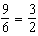

REF: 061905geo

5 ANS: 4
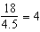

REF: 011901geo

6 ANS: 1
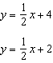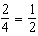

REF: 012008geo

7 ANS: 2

REF: 082412geo

8 ANS: 1
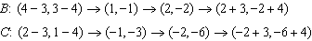

REF: 011713geo

9 ANS: 4
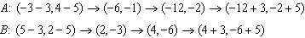

REF: 012322geo

10 ANS: 2 REF: 012416geo

11 ANS: 2 REF: 082417geo

12 ANS: 2
The given line h, , does not pass through the center of dilation, the origin, because the y-intercept is at . The slope of the dilated line, m, will remain the same as the slope of line h, -. All points on line h, such as , the y-intercept, are dilated by a scale factor of 4; therefore, the y-intercept of the dilated line is because the center of dilation is the origin, resulting in the dilated line represented by the equation .

REF: spr1403geo

13 ANS: 2 REF: 012518geo

14 ANS: 4
Another equation of line t is . 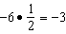

REF: 012319geo

15 ANS: 2
The line does not pass through the center of dilation, so the dilated line will be distinct from . Since a dilation preserves parallelism, the line and its image will be parallel, with slopes of 2. To obtain the y-intercept of the dilated line, the scale factor of the dilation, , can be applied to the y-intercept, . Therefore, 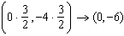. So the equation of the dilated line is .

REF: fall1403geo

16 ANS: 4
The line does not pass through the center of dilation, so the dilated line will be distinct from . Since a dilation preserves parallelism, the line and its image will be parallel, with slopes of . To obtain the y-intercept of the dilated line, the scale factor of the dilation, , can be applied to the y-intercept, . Therefore, 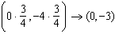. So the equation of the dilated line is .

REF: 011924geo

17 ANS: 2
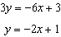

REF: 062319geo

18 ANS: 4
The line passes through the center of dilation, so the dilated line is not distinct.

REF: 081524geo

19 ANS: 2
The line passes through the center of dilation, so the dilated line is not distinct.

REF: 061824geo

20 ANS: 1 REF: 062424geo

