1 As shown in the diagram below, is a median of .
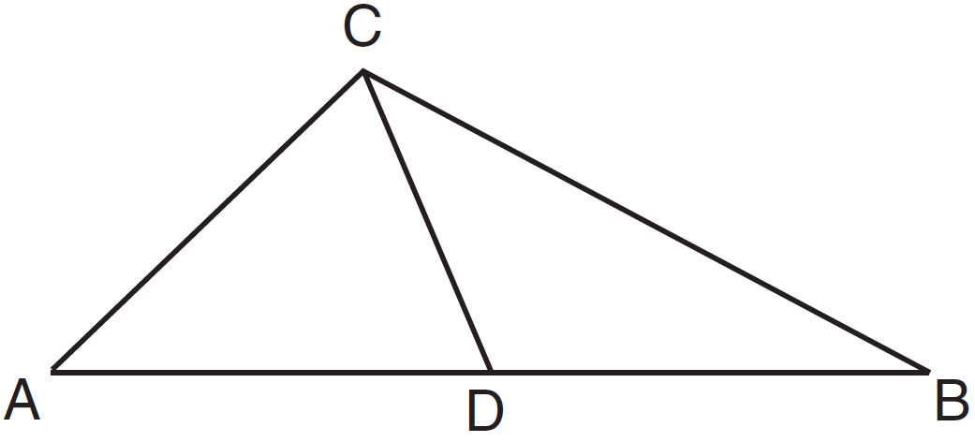
Which statement is always true?
1)
2)
3)
4)

2 Scalene triangle JKL is drawn below.
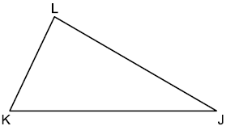
If median is drawn to side , which statement is always true?
1)
2) | 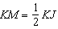
3)
4)

3 Given with base , median , altitude , and bisects , which conclusion is valid?
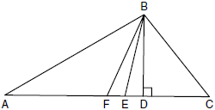

1)
2)
3)
4)

4 Given: , is the perpendicular bisector of

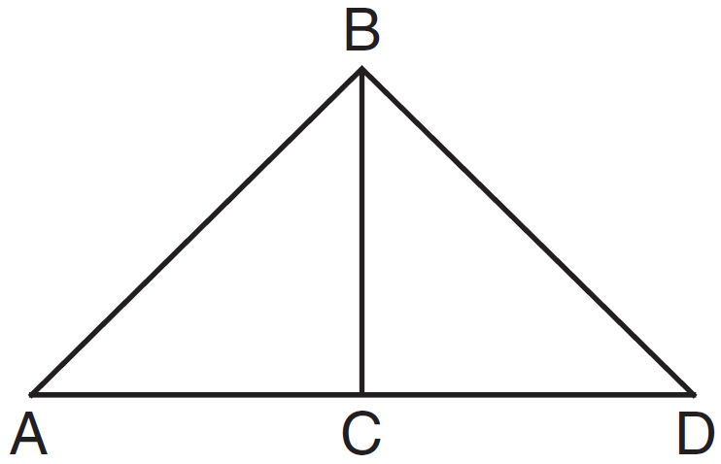

Which statement can not always be proven?
1)
2)
3)
4)

5 In triangle MAH below, is the perpendicular bisector of .

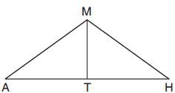

Which statement is not always true?
1) | is isosceles.
2) | is isosceles.
3) | bisects .
4) | and are complementary.

6 In , D is a point on such that is a median. Which statement must be true?
1)
2)
3)
4)

7 Segment AB is the perpendicular bisector of at point M. Which statement is always true?
1)
2)
3)
4)

8 In , is the perpendicular bisector of . Based upon this information, which statements below can be proven?
I. is a median.
II. bisects .
III. is isosceles.
1) | I and II, only
2) | I and III, only
3) | II and III, only
4) | I, II, and III

9 In isosceles , line segment NO bisects vertex , as shown below. If , find the length of and explain your answer.

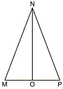
1 ANS: 1 REF: 011303ge

2 ANS: 2 REF: 012509geo

3 ANS: 4
Median bisects so that .

REF: fall0810ge

4 ANS: 2 REF: 081301ge

5 ANS: 2 REF: 012012geo

6 ANS: 3 REF: 080608b

7 ANS: 1 REF: 012316geo

8 ANS: 4 REF: 081822geo

9 ANS:
is congruent to by SAS. Since , then by CPCTC. So must divide in half, and .

REF: fall1405geo

