1 In the diagram of and below, , , and .

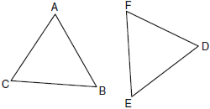

Which method can be used to prove ?
1) | SSS
2) | SAS
3) | ASA
4) | HL

2 As shown in the diagram below, bisects and .

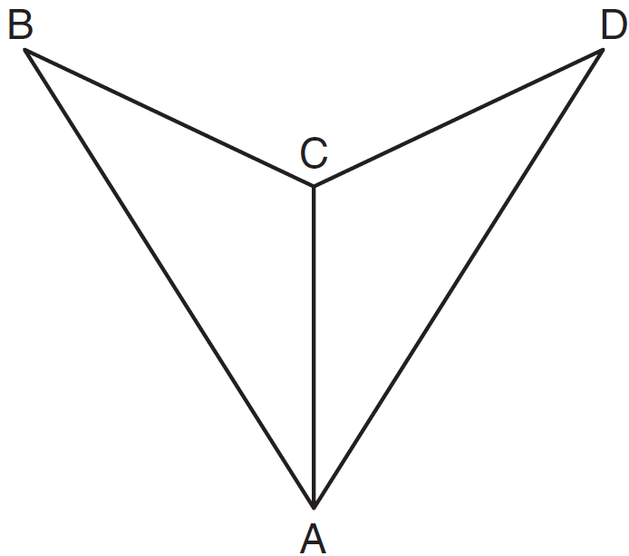

Which method could be used to prove ?
1) | SSS
2) | AAA
3) | SAS
4) | AAS

3 In the diagram below of and , and intersect at E, such that and .

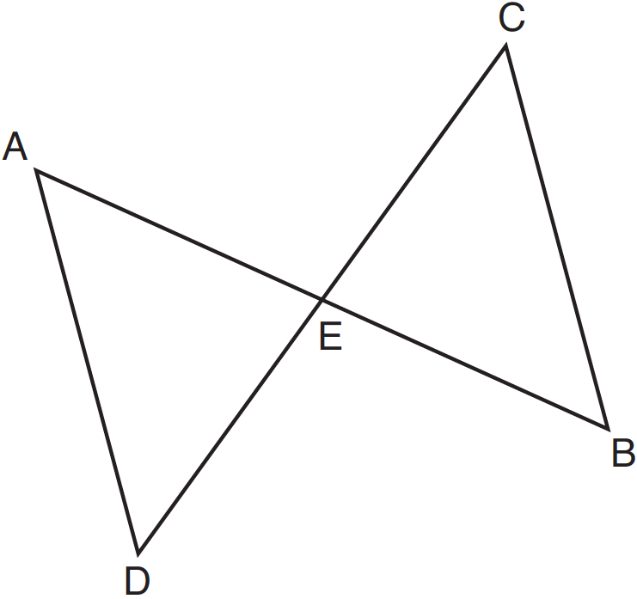

Triangle DAE can be proved congruent to triangle BCE by
1) | ASA
2) | SAS
3) | SSS
4) | HL

4 In the accompanying diagram of , , 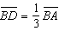, and 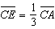.

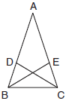

Triangle EBC can be proved congruent to triangle DCB by
1)
2)
3)
4)

5 In the accompanying diagram, bisects and .

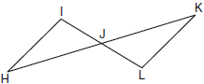

What is the most direct method of proof that could be used to prove ?
1)
2)
3)
4)

6 In the accompanying diagram, , , , , , and .

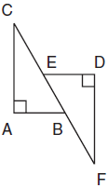

Which statement would not be used to prove ?
1)
2)
3)
4)

7 In the accompanying diagram of parallelogram ABCD, .

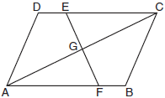

Triangle EGC can be proved congruent to triangle FGA by
1)
2)
3)
4)

8 Parallelogram ABCD with diagonal is drawn below. Line segment EF is drawn such that it bisects at M.

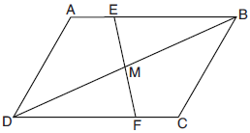

Which triangle congruence method would prove that ?
1) | ASA, only
2) | AAS, only
3) | both ASA and AAS
4) | neither ASA nor AAS

9 In the diagram of quadrilateral ABCD, , , and diagonal is drawn.
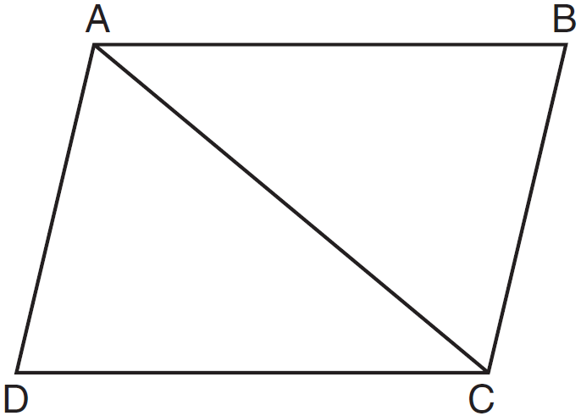
Which method can be used to prove is congruent to ?
1) | AAS
2) | SSA
3) | SAS
4) | SSS

10 In the accompanying diagram of triangles BAT and FLU, and .
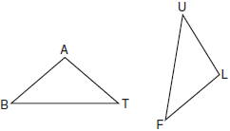
Which statement is needed to prove ?
1)
2)
3)
4)

11 In the diagram below of and , , and .
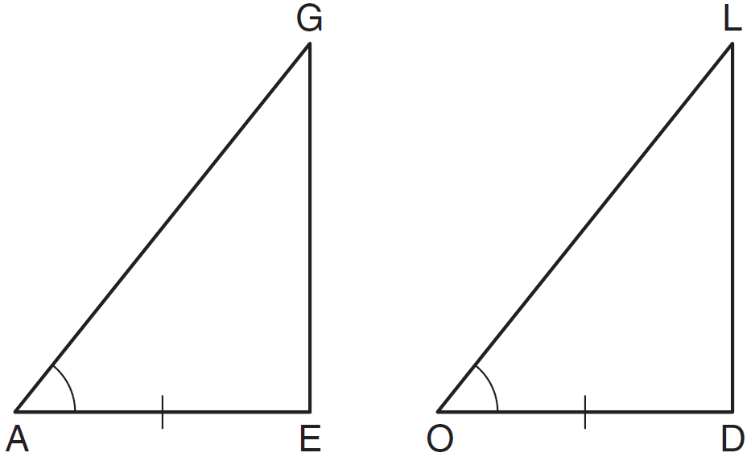
To prove that and are congruent by SAS, what other information is needed?
1)
2)
3)
4)

12 Given: and shown in the diagram below with

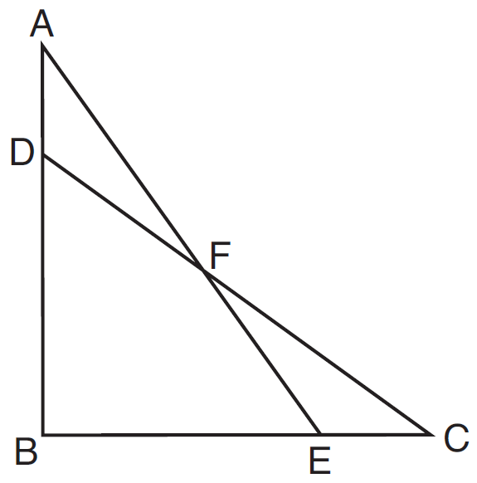

Which statement is needed to prove using only ?
1)
2)
3)
4)

13 Given: bisects at C
and are drawn

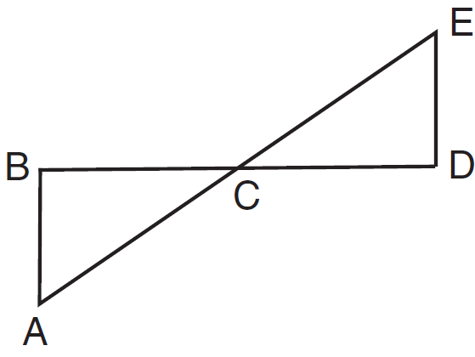

Which statement is needed to prove using ASA?
1) | and are right angles.
2) | bisects at C.
3)
4)

14 In the diagram below, , , , and are drawn such that .

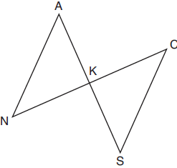

Which additional statement is sufficient to prove by AAS?
1) | and bisect each other.
2) | K is the midpoint of .
3)
4)

15 In the diagram below, and intersect at E.

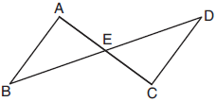

Which information is always sufficient to prove ?
1)
2) | and
3) | E is the midpoint of .
4) | and bisect each other.

16 In the diagram of triangles ABD and CBE below, sides and intersect at F, and .

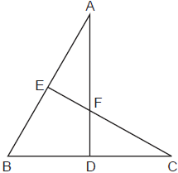

Which statement can not be proven?
1)
2)
3)
4)

17 In parallelogram ABCD shown below, diagonals and intersect at E.

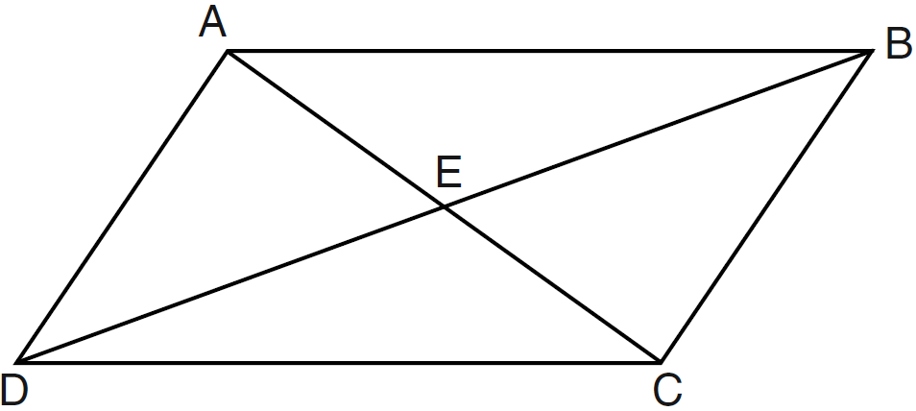

Which statement must be true?
1)
2)
3)
4)

18 Kelly is completing a proof based on the figure below.

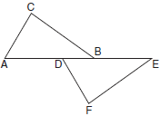

She was given that , and has already proven . Which pair of corresponding parts and triangle congruency method would not prove ?
1) | and SAS
2) | and SAS
3) | and AAS
4) | and ASA

19 In the diagram below, four pairs of triangles are shown. Congruent corresponding parts are labeled in each pair.

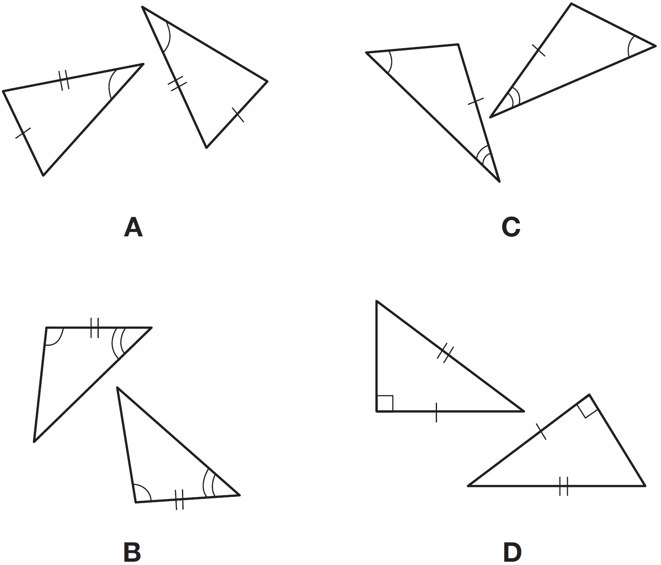

Using only the information given in the diagrams, which pair of triangles can not be proven congruent?
1) | A
2) | B
3) | C
4) | D

20 Two right triangles must be congruent if
1) | an acute angle in each triangle is congruent
2) | the lengths of the hypotenuses are equal
3) | the corresponding legs are congruent
4) | the areas are equal

21 Which condition does not prove that two triangles are congruent?
1)
2)
3)
4)

22 The diagonal is drawn in parallelogram ABCD. Which method can not be used to prove that ?
1) | SSS
2) | SAS
3) | SSA
4) | ASA

23 Given and with , which additional statement is sufficient to always prove ?
1) | and
2) | and
3) | and
4) | and

24 Which statements could be used to prove that and are congruent?
1)
2)
3)
4)

25 In and , and . Write one additional statement that could be used to prove that the two triangles are congruent. State the method that would be used to prove that the triangles are congruent.

26 In , , , and . In , , , and . Brett claims and . Is Brett correct? Explain why.
1 ANS: 3
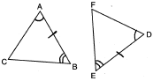

REF: 060902ge

2 ANS: 4
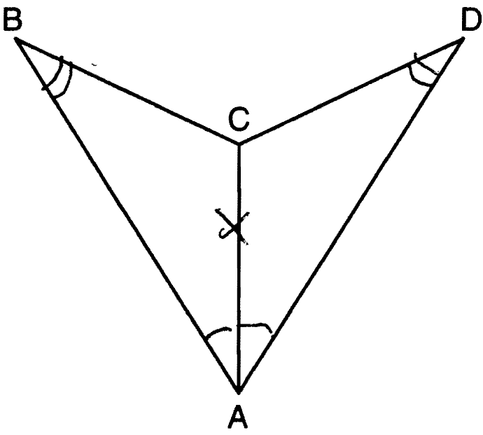

REF: 081114ge

3 ANS: 1
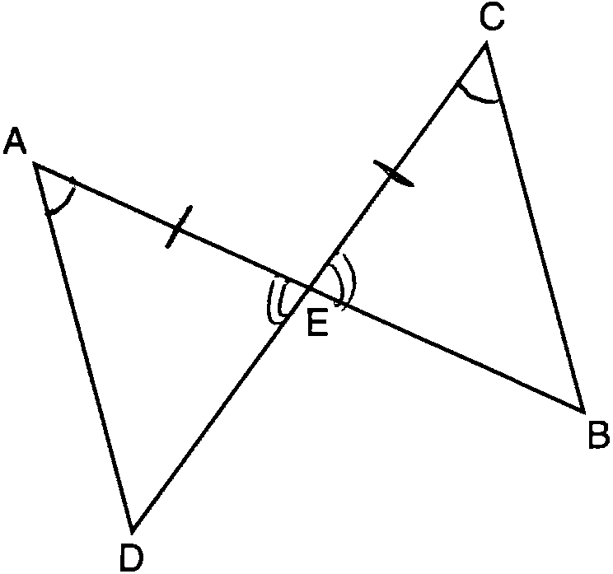

REF: 081210ge

4 ANS: 1
Since is an isosceles triangle and 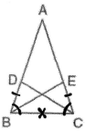.

REF: 060204b

5 ANS: 3
Because bisects , and are congruent vertical angles. Since is given, . 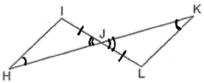

REF: 060420b

6 ANS: 1
Since 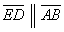 and is a transversal, and are alternate interior angles and congruent. can not be used because no statement is made that and are congruent. 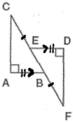

REF: 060320b

7 ANS: 3
and are congruent vertical angles. Because ABCD is a parallelogram, and since Because ABCD is a parallelogram, 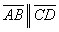 and since is a transversal, and are alternate interior angles and congruent. 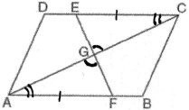. This problem can also be solved using elimination. Since they are not right triangles, HL does not apply, AAA only proves similarity and SSA does not prove congruence.

REF: 080310b

8 ANS: 3
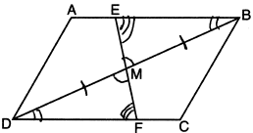

REF: 082217geo

9 ANS: 1 REF: 011122ge

10 ANS: 1 REF: 080907b

11 ANS: 2
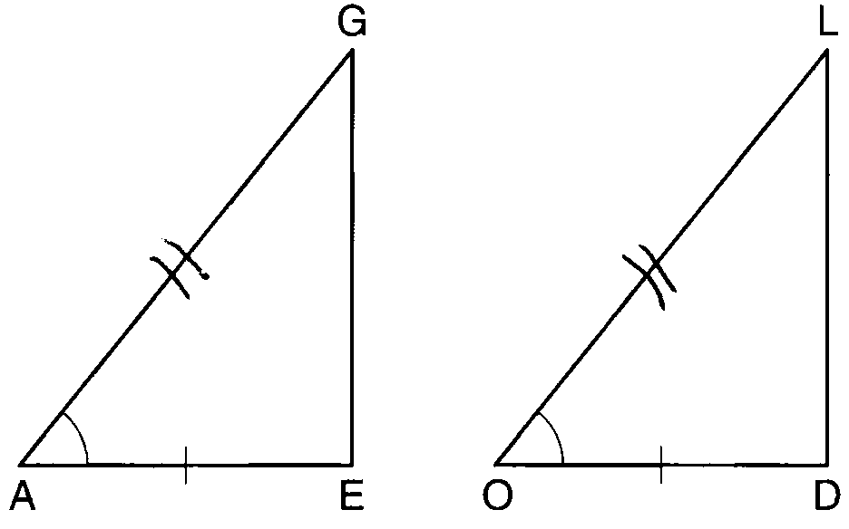

REF: 081007ge

12 ANS: 3 REF: 081622geo

13 ANS: 3 REF: 011627ge

14 ANS: 4 REF: 081810geo

15 ANS: 4
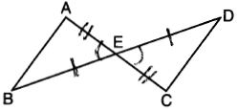

REF: 061908geo

16 ANS: 1
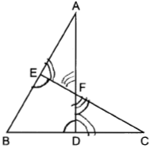

REF: 012423geo

17 ANS: 3
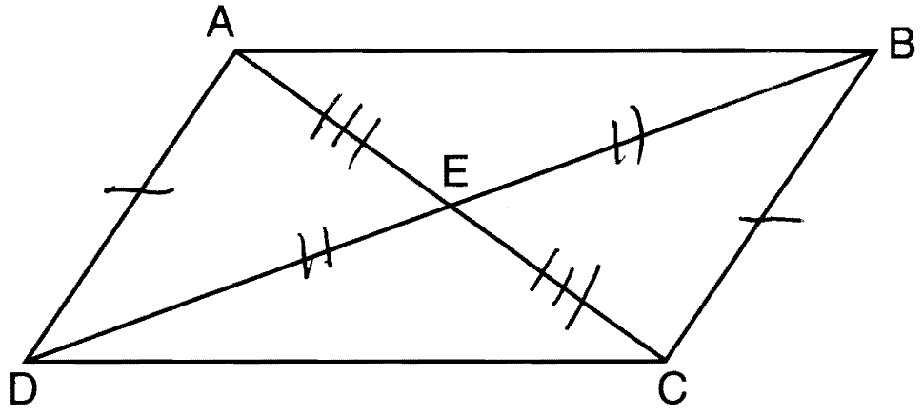. Opposite sides of a parallelogram are congruent and the diagonals of a parallelogram bisect each other.

REF: 061222ge

18 ANS: 2 REF: 061709geo

19 ANS: 1 REF: 011412ge

20 ANS: 3
1) only proves AA; 2) need congruent legs for HL; 3) SAS; 4) only proves product of altitude and base is equal

REF: 061607geo

21 ANS: 2 REF: 080401b

22 ANS: 3 REF: 080913ge

23 ANS: 2
SAS

REF: 012505geo

24 ANS: 2
(2) is AAS, which proves congruency. (1) and (4) are SSA and (3) is AAA.

REF: 010306b

25 ANS:
and ASA, or and AAS, or and SAS

REF: 011022b

26 ANS:
Yes. and are both 5-12-13 triangles and therefore congruent by SSS. All congruent triangles are similar.

REF: 012329geo

