1 A carpenter leans an extension ladder against a house to reach the bottom of a window 30 feet above the ground. As shown in the diagram below, the ladder makes a 70° angle with the ground. To the nearest foot, determine and state the length of the ladder.

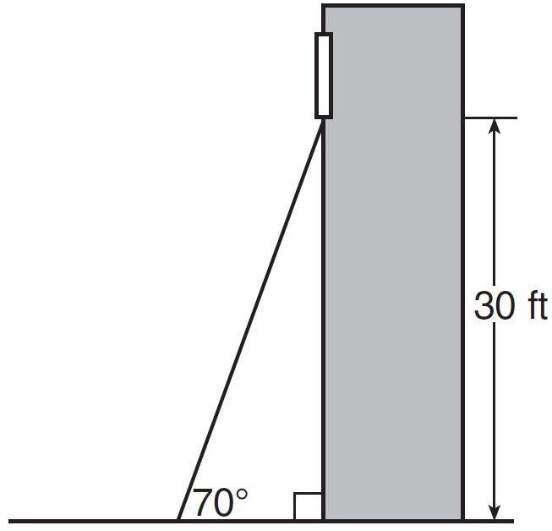

2 In the diagram below, a window of a house is 15 feet above the ground. A ladder is placed against the house with its base at an angle of 75° with the ground. Determine and state the length of the ladder to the nearest tenth of a foot.

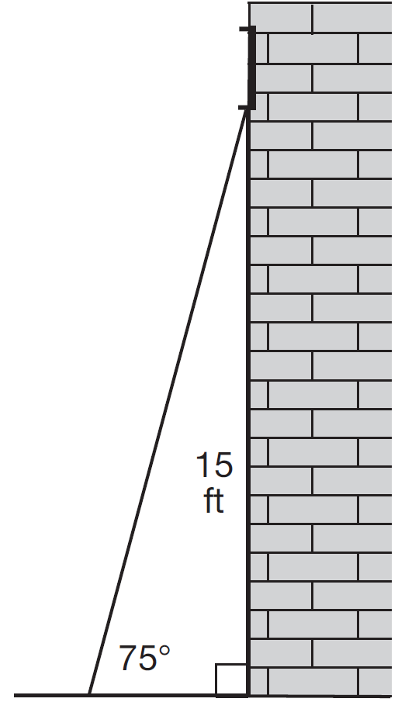

3 Diego needs to install a support beam to hold up his new birdhouse, as modeled below. The base of the birdhouse is inches long. The support beam will form an angle of 38° with the vertical post. Determine and state the approximate length of the support beam, x, to the nearest inch.

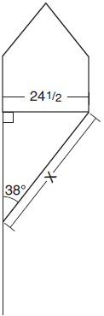

4 The Leaning Tower of Pisa in Italy is known for its slant, which occurred after its construction began. The angle of the slant is 86.03° from the ground. The low side of the tower reaches a height of 183.27 feet from the ground.

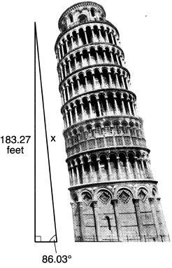

Determine and state the slant height, x, of the low side of the tower, to the nearest hundredth of a foot.

5 A person observes a kite at an angle of elevation of 32° from a line of sight that begins 4 feet above the ground, as modeled in the diagram below. At the moment of observation, the kite is 70 feet above the ground.

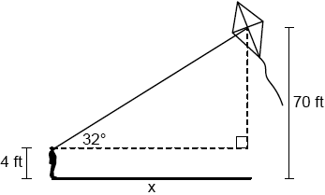

Determine and state the horizontal distance, x, between the person and the point on the ground directly below the kite, to the nearest foot.

6 A dog sees a bird in a tree. The angle of elevation from the dog’s eyes to the bird is 36°, as modeled below.

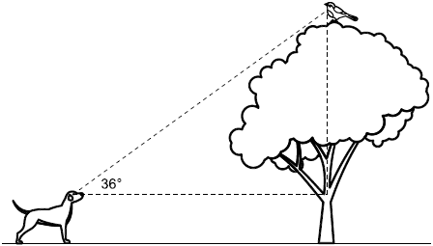

The dog is 18.5 feet away from the base of the tree, and his eyes are 2.5 feet above the ground. Determine and state how high the bird is above the ground, to the nearest foot.

7 A rock-climbing wall at a local park has a right triangular section that slants toward the climber, as shown in the picture below. The height of the wall is 5 meters and the slanted section begins 1.2 meters up the wall at an angle of 14 degrees.

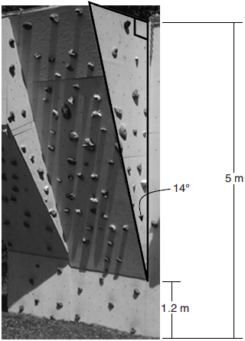

Determine and state, to the nearest hundredth, the number of meters in the length of the section of the wall that is slanted (hypotenuse).

8 As shown in the diagram below, an island (I) is due north of a marina (M). A boat house (H) is 4.5 miles due west of the marina. From the boat house, the island is located at an angle of 54° from the marina.

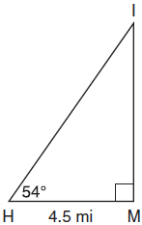

Determine and state, to the nearest tenth of a mile, the distance from the boat house (H) to the island (I). Determine and state, to the nearest tenth of a mile, the distance from the island (I) to the marina (M).

9 A telephone pole 11 meters tall needs to be stabilized with a support beam, as modeled below.

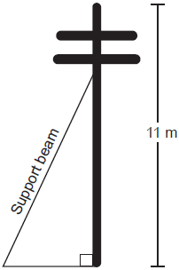

Two conditions for proper support are:
• The beam reaches the telephone pole at 70% of the telephone pole’s height above the ground.
• The beam forms a 65° angle with the ground.
Determine and state, to the nearest tenth of a meter, the length of the support beam that meets these conditions for this telephone pole. Determine and state, to the nearest tenth of a meter, how far the support beam must be placed from the base of the pole to meet the conditions.

10 Barry wants to find the height of a tree that is modeled in the diagram below, where is a right angle. The angle of elevation from point A on the ground to the top of the tree, H, is 40°. The angle of elevation from point B on the ground to the top of the tree, H, is 80°. The distance between points A and B is 85 feet.

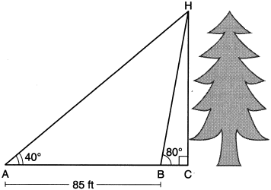

Barry claims that is isosceles. Explain why Barry is correct. Determine and state, to the nearest foot, the height of the tree.

11 A drone is used to measure the size of a brush fire on the ground. Segment AB represents the width of the fire, as shown below. The drone calculates the distance to point B to be 1076 feet at an angle of depression of 25°. At the same point, the drone calculates the distance to point A to be 774 feet at an angle of depression of 36°.

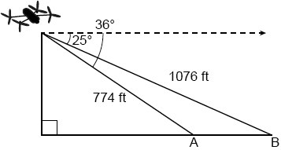

Determine and state the width of the fire, , to the nearest foot.

12 Cathy wants to determine the height of the flagpole shown in the diagram below. She uses a survey instrument to measure the angle of elevation to the top of the flagpole, and determines it to be 34.9°. She walks 8 meters closer and determines the new measure of the angle of elevation to be 52.8°. At each measurement, the survey instrument is 1.7 meters above the ground.

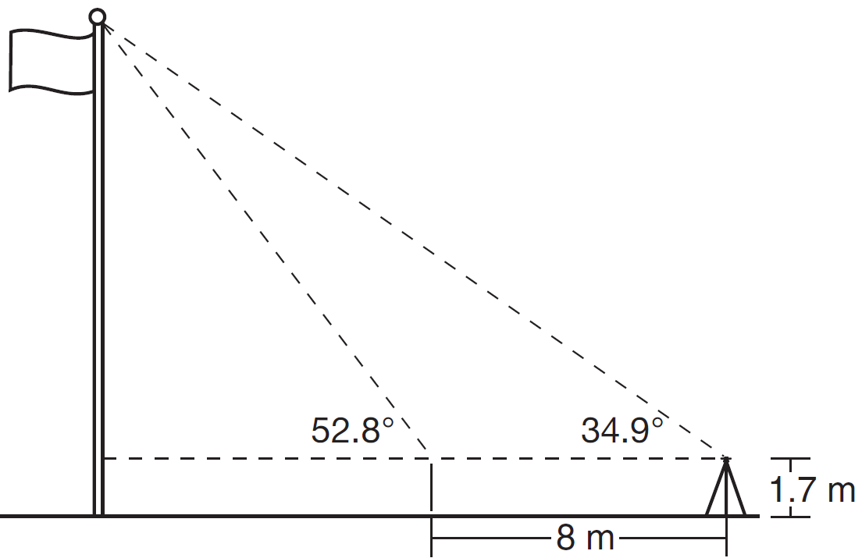

Determine and state, to the nearest tenth of a meter, the height of the flagpole.

13 Cape Canaveral, Florida is where NASA launches rockets into space. As modeled in the diagram below, a person views the launch of a rocket from observation area A, 3280 feet away from launch pad B. After launch, the rocket was sighted at C with an angle of elevation of 15°. The rocket was later sighted at D with an angle of elevation of 31°.

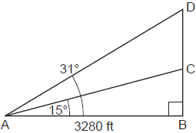

Determine and state, to the nearest foot, the distance the rocket traveled between the two sightings, C and D.

14 A homeowner is building three steps leading to a deck, as modeled by the diagram below. All three step rises, , , and , are congruent, and all three step runs, , , and , are congruent. Each step rise is perpendicular to the step run it joins. The measure of and .
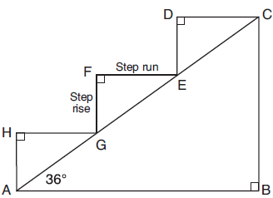
If each step run is parallel to and has a length of 10 inches, determine and state the length of each step rise, to the nearest tenth of an inch. Determine and state the length of , to the nearest inch.

15 As modeled in the diagram below, an access ramp starts on flat ground and ends at the beginning of the top step. Each step is 6 inches tall and 8 inches deep.
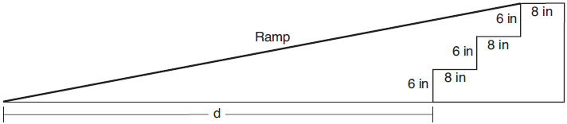
If the angle of elevation of the ramp is 4.76°, determine and state the length of the ramp, to the nearest tenth of a foot. Determine and state, to the nearest tenth of a foot, the horizontal distance, d, from the bottom of the stairs to the bottom of the ramp.

16 As shown below, a canoe is approaching a lighthouse on the coastline of a lake. The front of the canoe is 1.5 feet above the water and an observer in the lighthouse is 112 feet above the water.

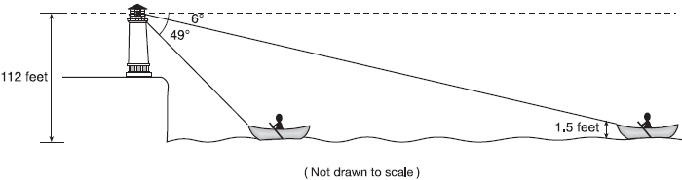

At 5:00, the observer in the lighthouse measured the angle of depression to the front of the canoe to be 6°. Five minutes later, the observer measured and saw the angle of depression to the front of the canoe had increased by 49°. Determine and state, to the nearest foot per minute, the average speed at which the canoe traveled toward the lighthouse.

17 The map below shows the three tallest mountain peaks in New York State: Mount Marcy, Algonquin Peak, and Mount Haystack. Mount Haystack, the shortest peak, is 4960 feet tall. Surveyors have determined the horizontal distance between Mount Haystack and Mount Marcy is 6336 feet and the horizontal distance between Mount Marcy and Algonquin Peak is 20,493 feet.

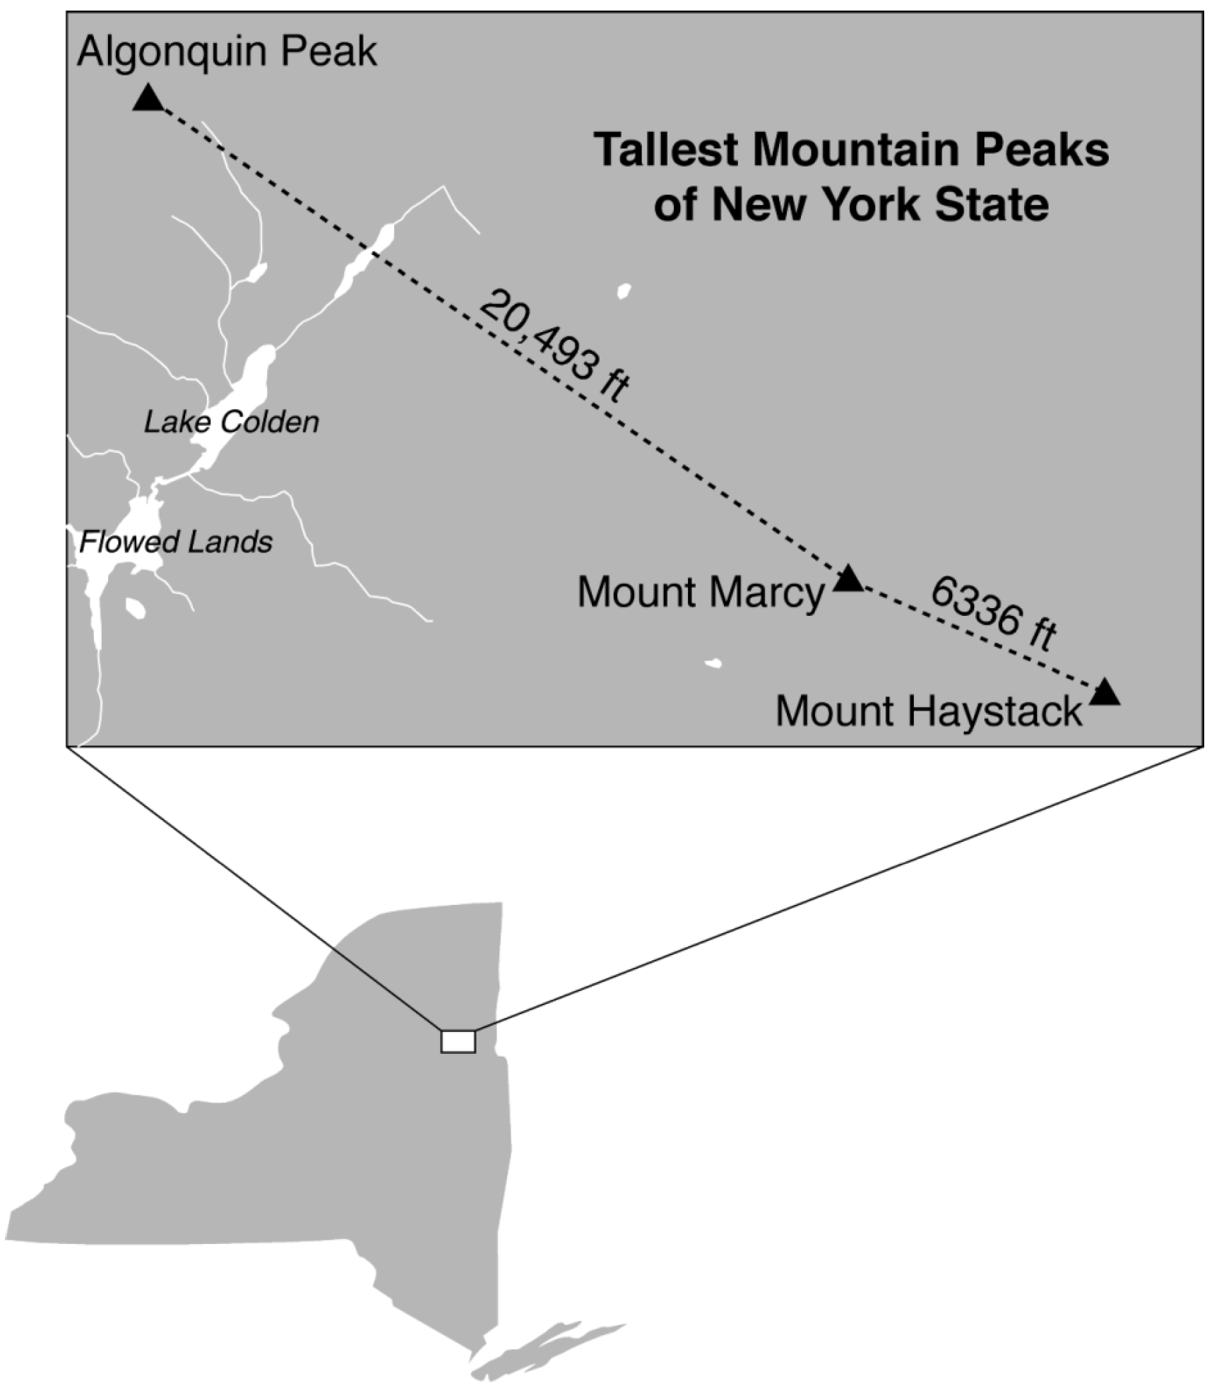

The angle of depression from the peak of Mount Marcy to the peak of Mount Haystack is 3.47 degrees. The angle of elevation from the peak of Algonquin Peak to the peak of Mount Marcy is 0.64 degrees. What are the heights, to the nearest foot, of Mount Marcy and Algonquin Peak? Justify your answer.

18 As shown in the diagram below, a ship is heading directly toward a lighthouse whose beacon is 125 feet above sea level. At the first sighting, point A, the angle of elevation from the ship to the light was 7°. A short time later, at point D, the angle of elevation was 16°.

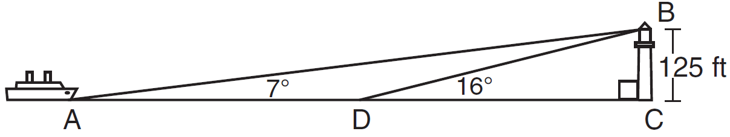

To the nearest foot, determine and state how far the ship traveled from point A to point D.

19 In the diagram below, a boat at point A is traveling toward the most powerful waterfall in North America, the Horseshoe Falls. The Horseshoe Falls has a vertical drop of 188 feet. The angle of elevation from point A to the top of the waterfall is 15°.

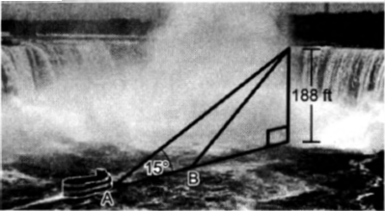

After the boat travels toward the falls, the angle of elevation at point B to the top of the waterfall is 23°. Determine and state, to the nearest foot, the distance the boat traveled from point A to point B.

20 The map of a campground is shown below. Campsite C, first aid station F, and supply station S lie along a straight path. The path from the supply station to the tower, T, is perpendicular to the path from the supply station to the campsite. The length of path is 400 feet. The angle formed by path and path is 72°. The angle formed by path and path is 55°.

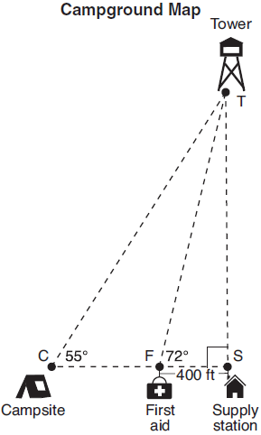

Determine and state, to the nearest foot, the distance from the campsite to the tower.

21 Nick wanted to determine the length of one blade of the windmill pictured below. He stood at a point on the ground 440 feet from the windmill's base. Using surveyor's tools, Nick measured the angle between the ground and the highest point reached by the top blade and found it was 38.8°. He also measured the angle between the ground and the lowest point of the top blade, and found it was 30°.

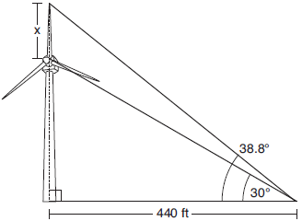

Determine and state a blade's length, x, to the nearest foot.

22 Trish is a surveyor who was asked to estimate the distance across a pond. She stands at point C, 85 meters from point D, and locates points A and B on either side of the pond such that A, D, and B are collinear.

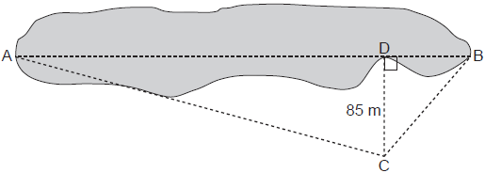

Trish approximates the measure of angle DCB to be 35° and the measure of angle ACD to be 75°. Determine and state the distance across the pond, , to the nearest meter.

23 David has just finished building his treehouse and still needs to buy a ladder to be attached to the ledge of the treehouse and anchored at a point on the ground, as modeled below. David is standing 1.3 meters from the stilt supporting the treehouse. This is the point on the ground where he has decided to anchor the ladder. The angle of elevation from his eye level to the bottom of the treehouse is 56 degrees. David's eye level is 1.5 meters above the ground.
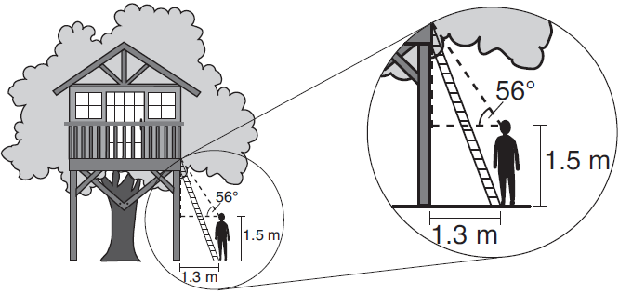
Determine and state the minimum length of a ladder, to the nearest tenth of a meter, that David will need to buy for his treehouse.

24 As modeled in the diagram below, a building has a height of 50 meters. The angle of depression from the top of the building to the top of the tree, T, is 13.3°. The angle of depression from the top of the building to the bottom of the tree, B, is 22.2°.
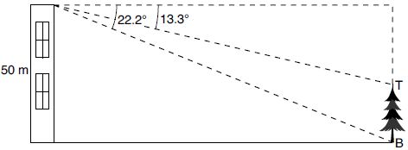
Determine and state, to the nearest meter, the height of the tree.

25 A flagpole casts a shadow on the ground 91 feet long, with a 53° angle of elevation from the end of the shadow to the top of the flagpole. Determine and state, to the nearest tenth of a foot, the height of the flagpole.

26 A support wire reaches from the top of a pole to a clamp on the ground. The pole is perpendicular to the level ground and the clamp is 10 feet from the base of the pole. The support wire makes a 68° angle with the ground. Find the length of the support wire to the nearest foot.

27 Freda, who is training to use a radar system, detects an airplane flying at a constant speed and heading in a straight line to pass directly over her location. She sees the airplane at an angle of elevation of 15° and notes that it is maintaining a constant altitude of 6250 feet. One minute later, she sees the airplane at an angle of elevation of 52°. How far has the airplane traveled, to the nearest foot? Determine and state the speed of the airplane, to the nearest mile per hour.
1 ANS:
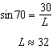

REF: 011629geo

2 ANS:
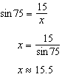

REF: 081631geo

3 ANS:
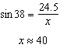

REF: 012026geo

4 ANS:
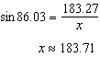

REF: 062225geo

5 ANS:
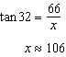

REF: 082428geo

6 ANS:
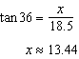

REF: 012527geo

7 ANS:
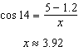

REF: 082228geo

8 ANS:
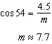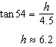

REF: 011834geo

9 ANS:
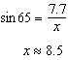. 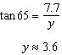

REF: 082333geo

10 ANS:
Since is 100°, is 40°. An isosceles triangle has two congruent angles. 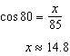 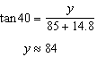

REF: 012334geo

11 ANS:
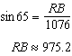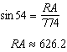

REF: 082432geo

12 ANS:
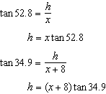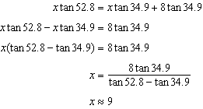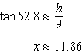

REF: 011636geo

13 ANS:
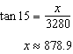; 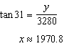;

REF: 062332geo

14 ANS:
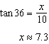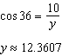

REF: 081833geo

15 ANS:
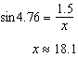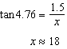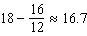

REF: 011934geo

16 ANS:
x represents the distance between the lighthouse and the canoe at 5:00; y represents the distance between the lighthouse and the canoe at 5:05. 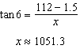 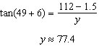 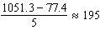

REF: spr1409geo

17 ANS:
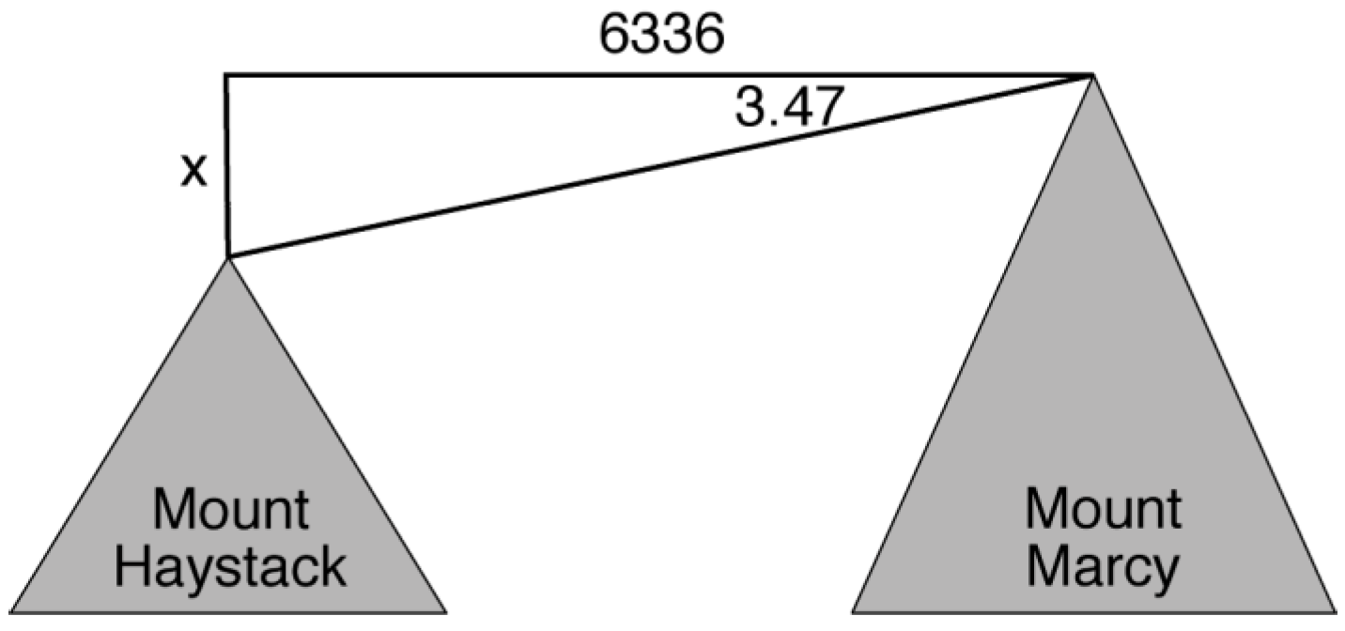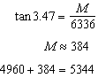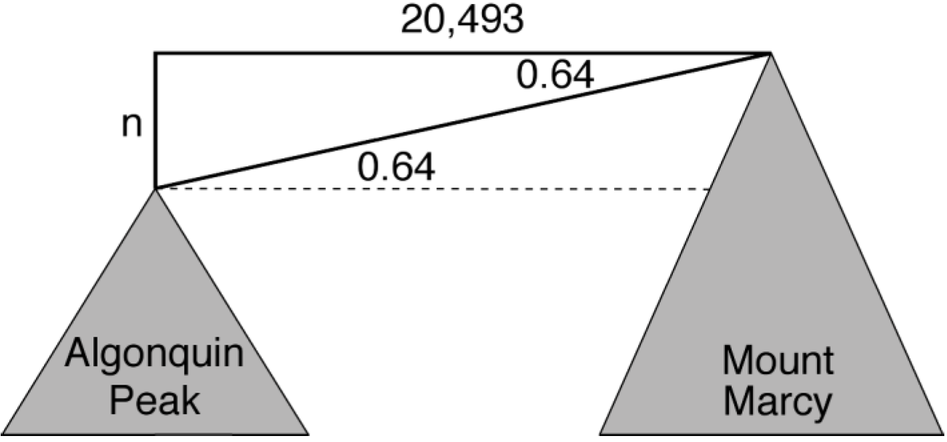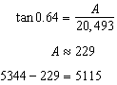
REF: fall1413geo

18 ANS:
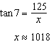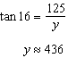
REF: 081532geo

19 ANS:
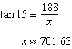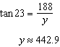
REF: 062434geo

20 ANS:
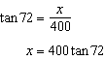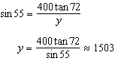
REF: 061833geo

21 ANS:
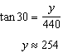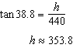
REF: 061934geo

22 ANS:
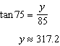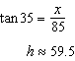
REF: 012432geo

23 ANS:
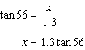
REF: 012033geo

24 ANS:
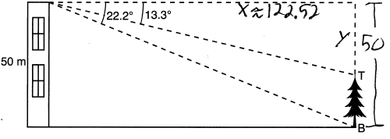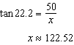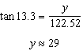
REF: 082232geo

25 ANS:
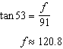
REF: 082327geo

26 ANS:
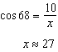
REF: 061927geo

27 ANS:
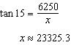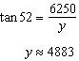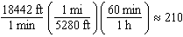
REF: 061736geo

