1 For all positive values of x, which expression is equivalent to ?
1) 2) 3) 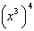 4)

2 The expression 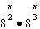 is equivalent to
1) 2) 3) 4)

3 Which expression is an equivalent form of ?
1) 2) 3) 4)

4 Which expression is equivalent to ?
1) 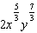 2) 3) 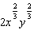 4)

5 The expression is equivalent to
1) 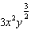 2) 3) 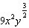 4)

6 For all positive values of x, which expression is equivalent to ?
1) 2) 3) 4)

7 Given , the expression can be rewritten as
1) 2) 3) 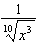 4)

8 If and , where , an expression for could be
1) 2) 3) 4)

9 Given , the expression 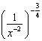 is equivalent to
1) 2) 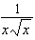 3) 4) 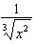

10 The expression 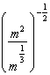 is equivalent to
1) 2) 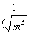 3) 4) 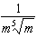

11 When and d is a positive integer, the expression 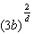 is equivalent to
1) 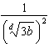 2) 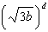 3) 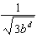 4) 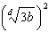

12 Which equation is equivalent to 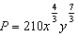
1) 2) 3) 4)

13 What does 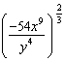 equal?
1) 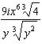 2) 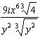 3) 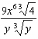 4) 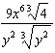

14 For , which expression is equivalent to 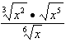?
1) 2) 3) 4)

15 For , which expressions are equivalent to one divided by the sixth root of x?
I. II. III.
1) I and II, only 2) I and III, only 3) II and III, only 4) I, II, and III

16 Given x and y are positive, which expressions are equivalent to ?

I. 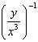 II. III. 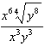
1) I and II, only 2) I and III, only 3) II and III, only 4) I, II, and III

17 For , which equation is false?
1) 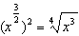 2) 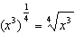 3) 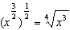 4) 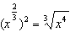

18 The expression 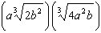 is equivalent to
1) 2) 3) 4)

19 Given , the expression is equivalent to
1) 2) 3) 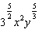 4) 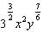

20 For positive values of x, which expression is equivalent to 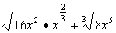
1) 2) 3) 4)
1 ANS: 1 REF: 062201aii

2 ANS: 1
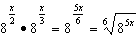

REF: 082419aii

3 ANS: 2
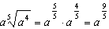

REF: 062306aii

4 ANS: 2
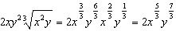

REF: 062413aii

5 ANS: 1
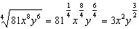

REF: 012001aii

6 ANS: 3
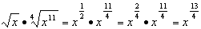

REF: 012511aii

7 ANS: 3
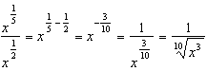

REF: 012312aii

8 ANS: 4
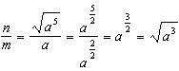

REF: 011811aii

9 ANS: 2
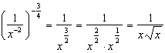

REF: 082412aii

10 ANS: 2
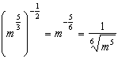

REF: 011707aii

11 ANS: 4 REF: 061601aii

12 ANS: 3
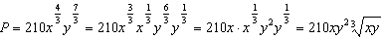
REF: 012413aii

13 ANS: 4
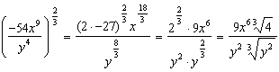
REF: 081723aii

14 ANS: 3
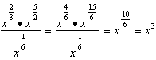
REF: 081812aii

15 ANS: 4 REF: 061716aii

16 ANS: 4
I. 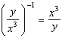; II. 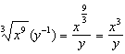; III. 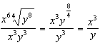
REF: 062320aii

17 ANS: 1
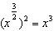
REF: 061908aii

18 ANS: 1
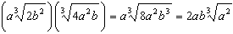
REF: 082213aii

19 ANS: 4
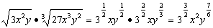
REF: 081914aii

20 ANS: 2
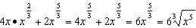
REF: 061820aii

