1 Write as a single term with a rational exponent.

2 Kenzie believes that for , the expression 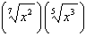 is equivalent to . Is she correct? Justify your response algebraically.

3 For n and , is the expression 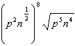 equivalent to ? Justify your answer.

4 When 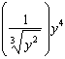 is written in the form , what is the value of n? Justify your answer.

5 Write 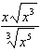 as a single term in simplest form, with a rational exponent.

6 Use the properties of rational exponents to determine the value of y for the equation:
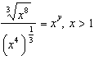

7 Given , use the properties of rational exponents to determine the value of x for the equation below.
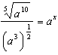

8 Justify why 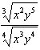 is equivalent to 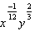 using properties of rational exponents, where and .

9 Express the fraction 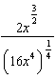 in simplest radical form.

10 For and , . Determine the value of a.

11 Given that 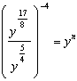, where , determine the value of n.

12 Given the equal terms and , determine and state y, in terms of x.

1 ANS:
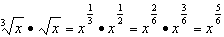

REF: 061731aii

2 ANS:
No. 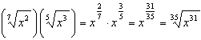

REF: 061929aii

3 ANS:
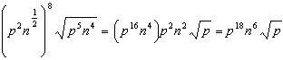

REF: 012025aii

4 ANS:
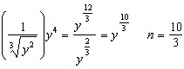

REF: 012428aii

5 ANS:
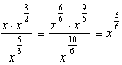

REF: 082331aii

6 ANS:
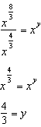

REF: spr1505aii

7 ANS:
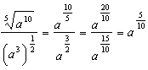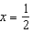

REF: 012528aii

8 ANS:
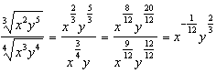

REF: 011925aii

9 ANS:
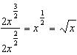

REF: 081826aii

10 ANS:
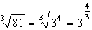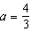
REF: 062230aii

11 ANS:
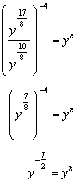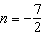
REF: 082228aii

12 ANS:
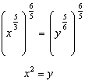
REF: 011730aii

