1 Expressed in simplest radical form, the product of is
1)
2)
3)
4)

2 Which value is equivalent to the product of and ?
1)
2)
3)
4)

3 Simplify:

4 Simplify:

5 Simplify:

6 The expression 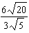 is equivalent to
1)
2)
3) | 8
4) | 4

7 Rationalize the denominator of the fraction below. Express the solution in simplest form.

8 Rationalize: 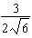

9 Simplify:

10 Simplify: 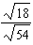

11 Simplify: 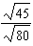

12 Express 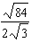 in simplest radical form.
1 ANS: 2
REF: 060627a

2 ANS: 1
REF: 061528ia

3 ANS:
REF: 119313al

4 ANS:
REF: 039505al

5 ANS:
REF: 039114al

6 ANS: 4
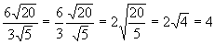
REF: 010622a

7 ANS:
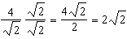
REF: 012530ai

8 ANS:
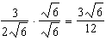
REF: fall2303ai

9 ANS:
REF: 119313al

10 ANS:
REF: 039505al

11 ANS:
REF: 099414al

12 ANS:
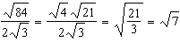
REF: 011431ia

