1 Betty conducted a survey of her class to see if they like pizza. She gathered 200 responses and 65% of the voters said they did like pizza. Betty then ran a simulation of 400 more surveys, each with 200 responses, assuming that 65% of the voters would like pizza. The output of the simulation is shown below.

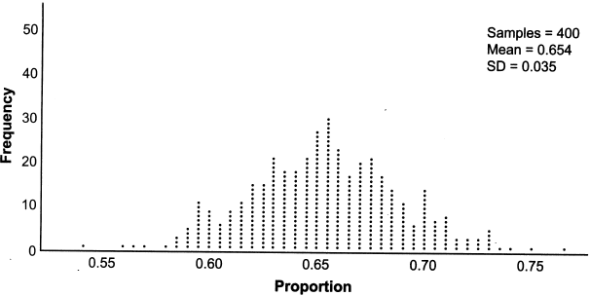

Considering the middle 95% of the data, what is the margin of error for the simulation?
1) | 0.01 | 3) | 0.05
2) | 0.02 | 4) | 0.07

2 A candidate for political office commissioned a poll. His staff received responses from 900 likely voters and 55% of them said they would vote for the candidate. The staff then conducted a simulation of 1000 more polls of 900 voters, assuming that 55% of voters would vote for their candidate. The output of the simulation is shown in the diagram below.

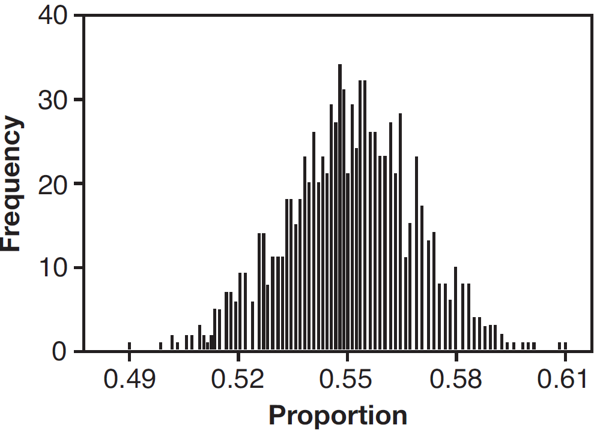

Given this output, and assuming a 95% confidence level, the margin of error for the poll is closest to
1) | 0.01 | 3) | 0.06
2) | 0.03 | 4) | 0.12

3 A study conducted in 2004 in New York City found that 212 out of 1334 participants had hypertension. Kim ran a simulation of 100 studies based on these data. The output of the simulation is shown in the diagram below.

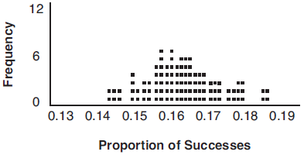

At a 95% confidence level, the proportion of New York City residents with hypertension and the margin of error are closest to
1) |  | 3)
2) |  | 4)

4 Marissa and Sydney are trying to determine if there is enough interest in their school to put on a senior musical. They randomly surveyed 100 members of the senior class and 43% of them said they would be interested in being in a senior musical. Marissa and Sydney then conducted a simulation of 500 more surveys, each of 100 seniors, assuming that 43% of the senior class would be interested in being in the musical. The output of the simulation is shown below.

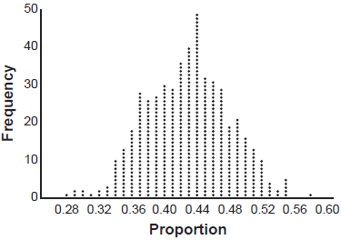

The standard deviation of the simulation is closest to
1) | 0.02 | 3) | 0.09
2) | 0.05 | 4) | 0.43

5 A group of students was trying to determine the proportion of candies in a bag that are blue. The company claims that 24% of candies in bags are blue. A simulation was run 100 times with a sample size of 50, based on the premise that 24% of the candies are blue. The approximately normal results of the simulation are shown in the dot plot below.

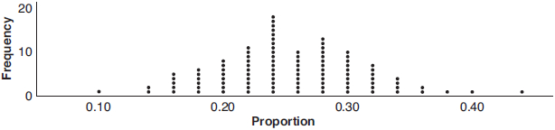

The simulation results in a mean of 0.254 and a standard deviation of 0.060. Based on this simulation, what is a plausible interval containing the middle 95% of the data?
1) |  | 3)
2) |  | 4)

1 ANS: 4

REF: 012319aii

2 ANS: 2
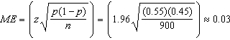 or 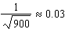

REF: 081612aii

3 ANS: 2
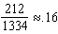 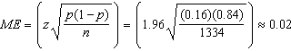 or 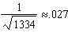

REF: 081716aii

4 ANS: 2
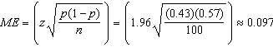 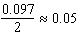 or 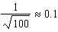 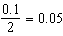

REF: 062317aii

5 ANS: 2

REF: 061913aii

